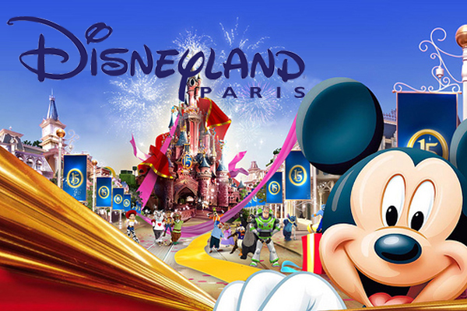

UNITY COLLEGE
DISNEYLAND PARIS TRIP
JUNE 2016
Mrs Brennan

