**Richard Kelly**

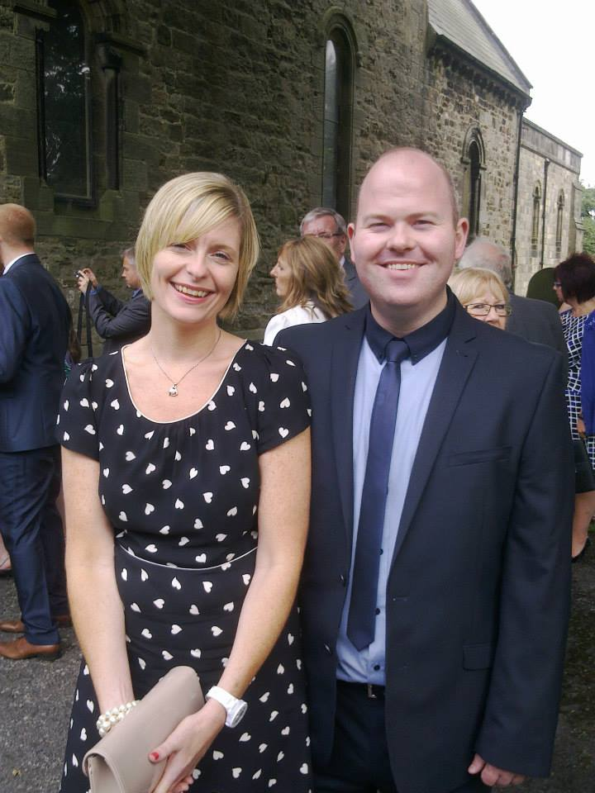

Having previously been a student of Towneley High school I am immensely proud to be a Governor. I really enjoyed my time at school and I can see the same dedication to students and ‘can do’ culture here at Unity College.

My professional background is within the IT industry and I presently work in Education with a senior role in IT strategy and E-learning. For the majority of my career I have been a manager supporting many different types of customer and have always worked (and lived) in or around the Burnley area. This had given me first-hand understanding of the needs of the community and the critical role education plays in all our lives.

With a teenage daughter at a local college, a son and daughter both attending local primary schools and also working in education I hopefully have developed a good appreciation for the challenges and opportunities within the sector.

My role as a governor allows me to give something back to the school and be part of a team that ensures Unity pupils receive the best possible experiences and outcomes from the education.

~~~~~~~~~~~~~~~~~~~~~~~~~~~~~~~~~~~~~~~~~~~~~~~~~~~~~

**Raynor Pepper**



When my daughter started Unity, I was overwhelmed with the Unity ethos and strategies for learning and was pleased to become a governor having been a previous student of Towneley and residing in Burnley all my life.

In my professional background I am a Director of two companies and also run a management company, working within these I have overseen and managed, recruitment, training, development and PR. Within one of my companies I manage and coordinate a whole host of community events which has given me first-hand knowledge of the important role Unity College has within our community and an understanding of what challenges the school has to overcome whilst creating the maximum opportunities for all our students.

My daughter has thrived at Unity College and this only motivates me more to ensure all students have every opportunity to leave Unity as well educated and well-rounded adults.

Sitting on the Governing body and working as a team we can move towards ensuring each and every student maximises on their potential and moves forward into successful careers.

**Helen Laycock**



I became a Foundation Trust Governor in October 2013 when my son started at Unity College in September of the same year.

My professional background is within the music and recording industry where I am the manager for a schools music and recording project, which offers a fun learning experience for key stage 1 and 2 children and also provides a unique fundraising tool for the schools.

Outside of the recording project I am also a manager for a local under 13 cricket team which is a new experience for me; however I am thoroughly enjoying the new challenges.

Being a governor at Unity allows me to further give something back to the community and help ensure that all pupils within the college gain the best life-enriching experience from the education provided.

~~~~~~~~~~~~~~~~~~~~~~~~~~~~~~~~~~~~~~~~~~~~~~~~~~~~~

**Anne Kelly**

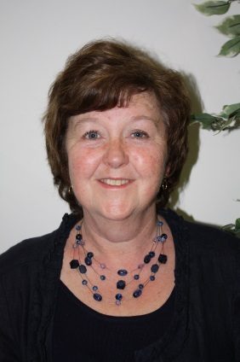

I have been a Governor at Unity College for 6 years and Chair for 2 years, as well as being Chair of the Standards and Curriculum Committee and a member of the Community Partnership Committee.

I am Councillor for the Ward of Briercliffe where I have lived for most of my life.

I loved being a Primary School teacher for 30 years and have always been involved in education in Burnley. My 3 children all went to Towneley High School and now my Grandchildren are here at Unity. The building and resources are brilliant but what I love best are the enthusiasm and dedication of everyone involved in the care and education of the students. As a Governor I want to support that commitment to the students.

**Diane Wilkinson**



My name is Diane Wilkinson and I have been a governor for approx. 25 years. Firstly at Towneley High School where my son and daughter both attended, then at Unity College.

I am a member of the Community Partnership, Curriculum, Learning and Teaching and Pupil Discipline Committees. I have been Special Educational Needs Governor for approx. 20 years a role which I enjoy and find extremely rewarding.

It is a privilege to be part of a very successful college which aims to provide an excellent education and the necessary life skills to achieve the full potential of all our students.

~~~~~~~~~~~~~~~~~~~~~~~~~~~~~~~~~~~~~~~~~~~~~~~~~~~~~

**Kerry Gorrell**

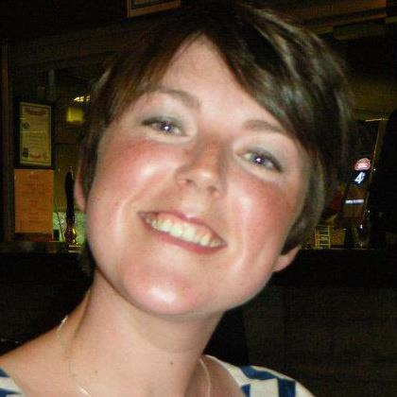

My current role at Springfield Community Primary School in Burnley is as Year 6 teacher and Key Stage Two Leader. As the majority of children I have taught move onto Unity College, it is important for me, as governor, to have a strong working relationship with the school in order to support transition. I enjoy my time at Unity College and often visit with pupils to take part in Science Clubs organised by the Science department or guided tours by Treasure Island.

I have worked in education for twelve years, the majority of which has been spent developing Literacy and teaching Year 6 classes in Leicestershire and Lancashire. As a Year 6 teacher, I understand the pressures and stresses of transition for high school, both for the children and the staff, and have worked closely with various secondary schools to further support these needs.

Being a Governor at Unity College enables me to continue to contribute towards shaping the future of our children’s lives and providing them with the best educational opportunities. Unity College is already a thriving school and I would like to help that continue into the future.

**Debi Hardie**



My professional background is within education as a Teacher of Sociology. I have taught in Burnley for the past twenty years and have been fortunate to teach the subject at both A level and GCSE to many students. I am currently at Thomas Whitham Sixth Form on Barden Lane, Burnley where I teach many fantastic students, including a number from Unity College!

I am a member of the Curriculum Committee and am pleased to be involved in looking at ways of further enhancing the educational experiences of students.

I really enjoy my involvement as a governor at Unity College and look forward to seeing the college and its students continue to excel.

~~~~~~~~~~~~~~~~~~~~~~~~~~~~~~~~~~~~~~~~~~~~~~~~~~~~~

**Humera Khan**



I have always been extremely proud of being from Burnley and been educated in the town. My experiences of High School and Sixth Form were extremely positive and stood me in good stead when I later moved on to University and a career. The values Unity instils in its students are at the core of success in any field and I am proud to be part of a governing team that ensures this happens.

My professional background is within Education and I have a management role developing the English and Maths provision both in our College and the local area. My role gives me a detailed knowledge of teaching and learning, as well as an understanding of the requirements of key stakeholders in education, such as students, parents and staff.

Having been brought up in the town I am aware of the issues faced by families in the locality as well as some of the many success stories of students from the area. In my role as governor I am part of a team that would like to increase the number of success stories in the area, so every student has a positive outcome from their time in education and is equipped with the skills and experience to make a valuable contribution in the next stage of their lives.

**Toni Stott**



I have lived in the Briercliffe area of Burnley all my life. I am a full time mother, for the last 15 years I have worked as a dinner lady at 2 local primary schools. I have also been a volunteer in the classroom at the schools for most of that time. Both jobs I have enjoyed very much.

I have four boys who have all attended first Towneley High School and then Unity College. My youngest will take his GCSE’s next year. My three older boys have all gone on to have successful careers after all the hard work from the Towneley and Unity staff to make them achieve their full potential.

I have been a Governor since the conception of Unity in which I have seen the school grow into the exceptional place it is today. I am proud to have been elected for a third term of office at the school and look forward to being part of the team of staff, Governors and students that make this school so successful.

I am also on the Resources and Community Partnership committees and am Vice Chair of the Parent Council which gives parents the opportunity to have an input into the school.

~~~~~~~~~~~~~~~~~~~~~~~~~~~~~~~~~~~~~~~~~~~~~~~~~~~~~

**John Wilkinson**

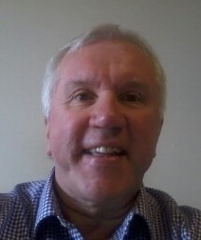

Because the education I received in Burnley enabled me to enjoy a rewarding and productive career I wish that every child in Burnley is given the best possible chance to have a real opportunity to do the same.

I’ve spent most of my career as a Finance Director and have worked in all sorts of industries at home and abroad. Experience as a Non-Executive Director on the board of East Lancashire NHS has given me an understanding of the importance of education in improving health and well-being. I offer a lifetime’s experience of how to manage and develop organisations and people and how to manage resources efficiently and effectively.

I am currently deputy Chair of the Governing Body and Chair of the Resources Committee. I consider myself very fortunate since 2009 to have been a governor of this wonderful college as it goes from strength to strength.

**Jean Fitzpatrick**



I have worked in the NHS since 1987 mainly in Primary Care. The last ten years have been spent with Health Education North West, responsible for postgraduate medical and dental education. I work as part of a team whose job is to assess the suitability of doctors and dentists in training, in addition to reviewing their annual progression.

I was keen to offer my time as governor to Unity College and have been on the board of governors for two years. I want to support the school in providing all students with the opportunities that will make them the best that they can be.

~~~~~~~~~~~~~~~~~~~~~~~~~~~~~~~~~~~~~~~~~~~~~~~~~~~~~

**Bev Worthington**

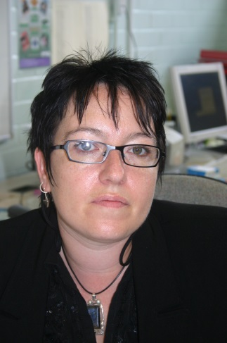

I have worked with young people and their families in Burnley for over 20 years. As a former student of Towneley High School I was honoured to be offered a post there 14 years ago to develop the Youth and Community team in school.

I moved to Unity College through the BSF programme and now have a lead role in college for student interventions for behaviour and emotional health & wellbeing.

My role as a governor has allowed me to contribute insight and knowledge as a Unity College staff member, whilst helping me to develop a wider ranging appreciation and understanding of the many diverse challenges involved in leading Unity College forward.

I am 100% committed towards moving Unity College to becoming an Outstanding school and supporting and motivating every Unity Student to be the best that they can be.