19 March 2019

Dear Parents / Guardian

PARENT GOVERNOR ELECTION

Further to my recent letter notifying you of the two parent governor vacancies and the subsequent ballot, I am now writing to inform you that following the ballot count on Monday 18 March the following two parents have been elected as parent governors for a four year term:-

Kelly Forrest
Kimberley Mullen

I would also like to take this opportunity of thanking the three other parents who put up for nomination, and also to the parents / guardians who took the time to vote in this election process.

Yours faithfully

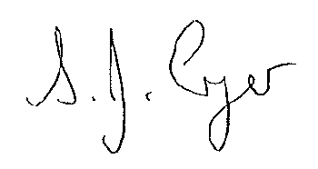

S Cryer (Mrs)
Headteacher (Returning Officer)

