Partial Closures – provisional plans
Wednesday 18 March 2020 – Friday 20 March 2020

In light of the government guidance anyone with symptoms of a new cough or high temperature should self-isolate for 14 days, along with members of their household. We have a significant number of staff who will be absent from work for the next 14 days due to this new guidance.

Regrettably this leaves us in a position where we are unable to operate as normal for all year groups. Having carefully considered the options, we have taken the decision to close to a year group per day between now and Friday 20 March. We will review this decision daily and will communicate with you as soon as we can via our website www.unity-college.com and by 7.30am each morning about any changes to these plans. If we have further staff absences it may be necessary for another year group to stay at home. If instructed to stay at home, students should follow the government guidelines regarding social distancing. They can access work on line via Show my Homework and BBC Bitesize.

If it is impossible to have your child at home please send them in and they will be supervised in a room doing private study / silent reading. They need to ensure that they have work / a reading book with them.

It is critical at this stage that year 11 stay in college due to their imminent GCSE examinations. Year 10 mock examinations will continue as planned (except for Friday). The year 10 mock examination planned for Friday will take place on Monday 23 March.

If any student presents any symptoms, in line with the government guidance, they should remain at home. If a student becomes ill at college with a new cough or a high temperature you will be contacted and they will be sent home.

I appreciate your support and look forward to returning to normal as soon as possible.

Yours sincerely
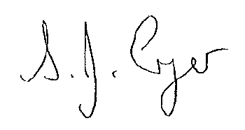
S Cryer (Mrs)
Headteacher

Partial Closures

Wednesday 18 March
- Year 8 to stay at home
- Years 7, 9, 10 and 11 to attend college as normal

Thursday 19 March 2020
- Year 7 to stay at home
- Years 8, 9, 10 and 11 to attend college as normal

Friday 20 March 2020
- Year 10 to stay at home
- Years 7, 8, 9, and 11 to attend college as normal

