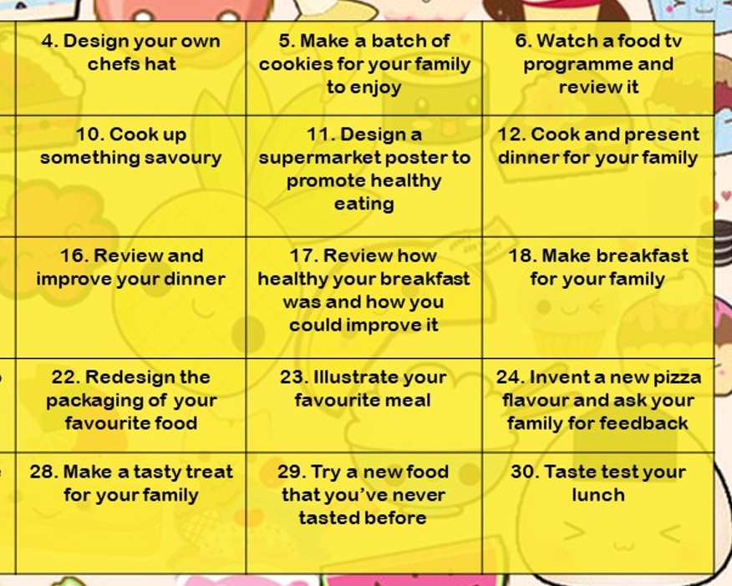
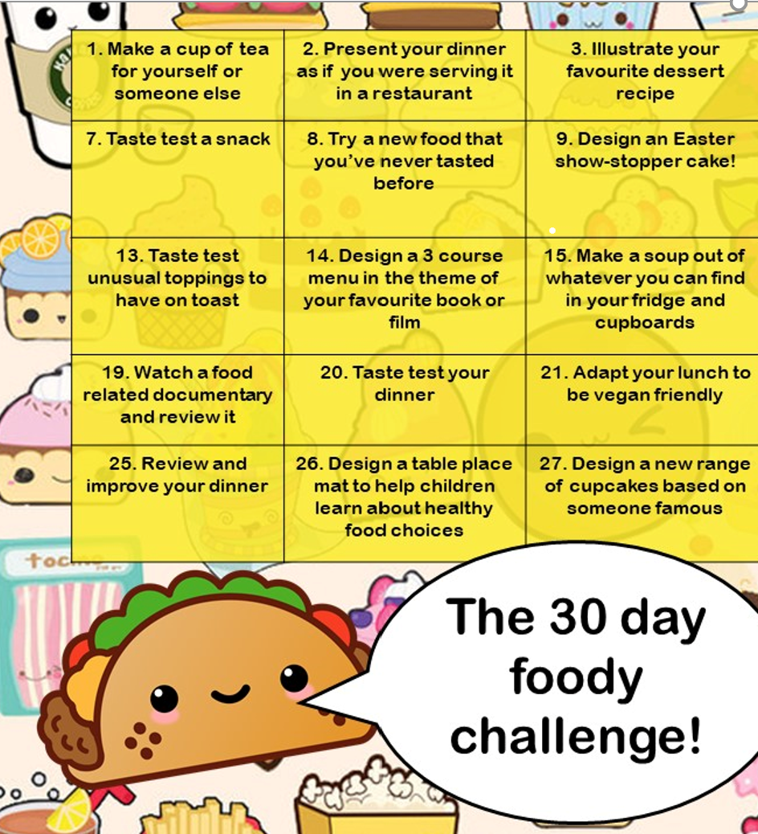
A fun way to do something foody every day! Do what you can, when you can – don’t worry if not in order or if you have to adapt them to what you have available. Enjoy!
9. Design a healthy summer cake.

