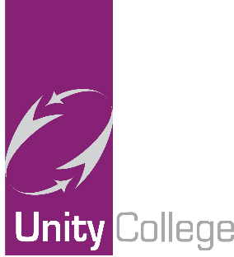

1 April 2020

Free School Meal Update

We hope you and your family are all well. This week many of you came and collected the Tesco vouchers towards your child’s free school meal entitlement. These are challenging times for all of us and we want to make sure that we can continue to provide the best possible support to our students/parents/guardians/carers during this period. We also want to thank you for your patience whilst collecting the vouchers and maintaining the social distancing protocol.

If you have not been able to collect your voucher, please do not worry; we are working on the latest government advice so that all vouchers can be issued electronically going forward. This will offer more flexible choice of shopping and enable us to get the vouchers to you faster and safer.

In order to do this we urgently need ALL parents/guardians/carers (even if you have collected your first round of vouchers) to email us at fsm@unity.lancs.sch.uk with your child’s full name and date of birth. The sooner we get this information verified the sooner we can begin to issue the next round of vouchers as they become due. If you have already supplied this information recently, and many of you have, you do not have to send it again.

If your circumstances have recently changed and you think you may be entitled to free school meals, please contact the Pupil Access Team at Lancashire County Council on 01254 220 747 or email pupil.accesseast@lancashire.gov.uk for assistance.

These are uncertain times and we are constantly responding to new Government advice, so plans may change. We encourage you to check the college website for regular updates.

Please continue to send any general queries or concerns about free school meals to fsm@unity.lancs.sch.uk and we will aim to respond as quickly as possible.

Thank you for your continued support and wishing you all the very best.

