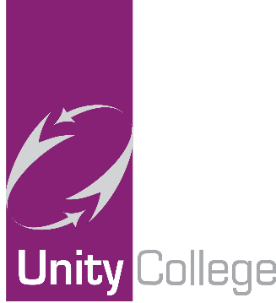

16 April 2020

National Free School Meal Voucher Scheme Update
Please be assured that we have uploaded and approved all eligible free school meal vouchers on the government portal in line with our update last week.
Unfortunately, due to the unprecedented demand for this service the system operated by Edenred on behalf of the DFE have experienced significant IT issues, which has led to delays to all parts of the registration, generation and distribution of vouchers. Please note this is beyond the control of individual schools, but we will, of course, continue to apply pressure through different channels to ensure delays are minimised.
We understand that the IT problem has now been fixed and the vouchers are working its way through the system slowly. Please keep checking your inbox regularly, including your spam/junk.
When checking your emails for your e-codes and e-voucher please note that it will come from noreply@edenred.co.uk.
You may also contact Edenred by emailing them at freeschoolmealsparentscarers@edenred.com for further updates and access more information on their FAQ page link below.
https://www.edenred.co.uk/Documents/DfE/DfE_FreeSchoolMeals_ParentCarerFAQs.pdf
If you have any other questions, please email us at fsm@unity.lancs.sch.uk.

