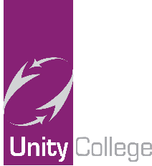

National Free School Meal Voucher Scheme Update 9 April 2020

We hope you and your family are keeping well.
A huge thank you to those who responded to our recent email request. We have received over 80% verified email responses and have started issuing electronic school meal vouchers through the national scheme, recently launched and supported by the Department for Education (DFE).
Our priority is to get all parents up-to-date, especially those who could not collect the Tesco vouchers. After a successful trial this week of distributing the electronic vouchers through the DFE, we will now issue the rest of the vouchers starting today. Those who collected the Tesco voucher for the first four weeks will receive the electronic vouchers from week commencing the 20th April 2020, after the Easter break.
The voucher will equate to £15 per eligible child per week. This funding will continue until your child returns to school.
Please note due to the volume of vouchers that are being issued nationally, it can take up to 7 days for the vouchers to come in your email inbox. Therefore, we would encourage you to check your email account regularly including your spam/junk mail folder.
The email will come with full instructions on how to download the electronic voucher for your chosen supermarket and thereafter can be used instantly.
If you still have not sent a verification email to fsm@unity.lancs.sch.uk giving the name of your child and their date of birth, please do so as soon as possible and we will add you to the scheme.
There have been reports of families, not any of ours, receiving scam emails and text messages from fraudsters asking for bank details in order to provide access to free school meal vouchers; note we will never ask for your bank details in order to supply the vouchers. If you receive such requests, please delete them immediately, as they are fraudulent.
If you have any queries, please continue to email us at fsm@unity.lancs.sch.uk.

