Design a Zoo Theme Park
This is an extracurricular project for you to do, over the holidays, which links with your Science, too. It will take around 9 hours to complete. You will need to look at the science activity first, in order to make a start on this project.
The aim of this project is to…
1. be able to design your own theme park ride, linking it to animals and conservation, being as creative as you can.
2. be able to use persuasive techniques to advertise and market your theme park.
3. be able to answer comprehension questions about a piece of text you have read, linked to theme parks.
4. be confident in spotting spelling and grammar errors in a piece of writing.

Task 1 - Getting started
This will take approximately 1 hour.
First of all, go to -
https://www.familytravelmagazine.com/20-virtual-theme-park-ride-tours/
➢ Spend some time visiting the different park rides and tours from various theme parks around the world.
Make a list of the types of rides and theme parks you like.
Now, using the animal which you have decided to focus on in science, design a theme park ride to reflect its appearance, character, habitat and movement. Take a look at the video… https://www.youtube.com/watch?v=szl_pAiRkJE .
This is a video taken of an old ride, from Blackpool Pleasure Beach, called the Wild Mouse. Notice how the ride darts from side to side, and makes swift, turning movements, similar to that of a mouse. How might your ride move? How could it reflect your animal? What would you call it?
My animal is _______________________________________and my ride is called___________________________
______________________________________________________________________________________________

Task 2
This will take 2 hours.
➢ Design your theme park ride. Ensure you incorporate details about the ride itself and information about the animal that it represents, on the design.
Success criteria tick list -
❑ Include several images of your ride, from different perspectives: from the side, a birds-eye view, the entrance, etc.
❑ Include some ‘facts’ - how fast it goes, how tall it is, how long it is, when it was built, what materials were used to build it. You may need to research other theme park rides to get some ideas. Also, use your imagination with lots of these details, but try to make it sound realistic.
❑ Detail information on how this ride can help to bring awareness of the conservation of your animal. For example, 20% of the ticket price for the theme park will go towards its conservation charity, informational talks as patrons are queueing, souvenirs and toys of the animal for sale, adopt an animal, etc.
❑ Write fun facts about your animal which could be displayed at the entrance, and inside, as people queue for the ride.

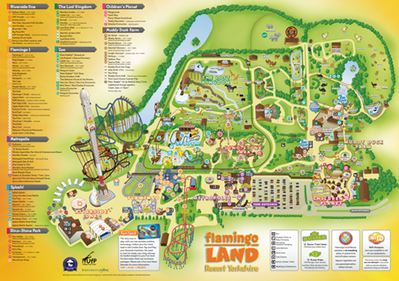
Task 3
This will take 2 hours
➢ Design the rest of your theme park, incorporating the animal enclosures. If you need some inspiration, take a look at the Flamingo Land and Busch Gardens’ websites. Both of these incorporate animals and rides into their theme parks.

Success criteria tick list
❑ How many species of animals will you include in your park?
❑ Should there be a river, pond or no open water?
❑ How many rides will you have? What will they be called?
❑ How big will each animal enclosure be?
❑ What sort of refreshments will you have available for patrons? Café? Restaurant? Food stands?
❑ How will the public view your animals? Platforms? Fences? Tanks?
❑ How will you educate the public about the conservation of the animals? Informational talks? Feeding times?

Task 4
This will take 2 hours
Open the ‘Task 4 Theme Park Writing’ PDF document to recap on persuasive techniques, and use the writing frame to format your writing.
➢ Create a persuasive leaflet for your theme park.

Success criteria tick list
❑ What is your theme park’s name?
❑ What amazing rides does your theme park offer?
❑ Does your theme park have ‘zones’, if so, what will they be?
❑ What species of animals does your theme park have?
❑ What special events happen at your theme park, to encourage visitors?
❑ What prices do you charge and are there any special offers?
❑ What catchy slogan will you use?
❑ Have you used superlatives and hyperbole (over exaggeration) to persuade people to visit?
❑ Are there any other persuasive techniques you can include?
Task 5
This will take 1 hour.
➢ Read the texts, A, B and C on Theme Parks and answer the comprehension questions.
If you want to challenge yourself, choose Challenge Comprehension Questions.
For support in answering the questions, choose Supported Comprehension Questions.
For prompts on how to answer comprehensions in general, choose Reading Comprehension Prompts.

Success criteria tick list
❑ Make sure you read the text 2 or more times, to become familiar with it.
❑ Skim and scan for key words to answer the questions.
❑ Answer the questions as clearly as you can – keep to the point.
❑ Read through, once you are finished, and check your answers.

Task 6
This will take 1 hour.
➢ Read the text on Thorpe Park and correct the 7 mistakes made.

Success criteria tick list
❑ Make sure you read the text 2 or more times, underlining anything you think may be incorrect.
❑ Use a dictionary to help, if you are unsure of any spellings.
❑ Rewrite the errors correctly at the bottom of the sheet.
❑ Read through, once you are finished, and check your answers.

Finally…
Have I completed my English project?
❑ I have researched theme parks and animals to make an informed decision on my theme park design.
❑ I have designed an eye-catching theme park ride, to reflect the animal I have chosen for my Science project.
❑ I have designed a theme park which incorporates a zoo and park rides.
❑ I have written a piece of persuasive writing to encourage people to visit my theme park.
❑ I have completed the reading comprehension about Theme Parks.
❑ I have completed the Thorpe Park spelling and grammar activity.
When you have completed all 6 tasks, submit them to school FAO Miss. Smith, or K.Smith@unity.lancs.sch.uk

