Text A- Information about theme parks taken from themeparkreview.com
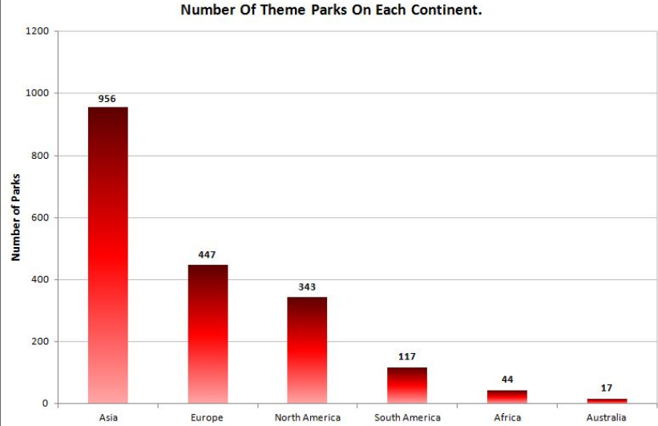

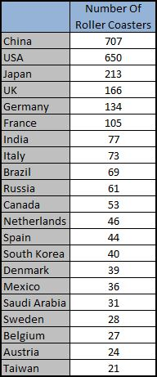

Text B
How to scare your Teenagers at Thorpe Park
Thorpe Park - Rollercoaster Central, the thrill capital of England, the most terrifying location inside the M25 – holds a special place in the affections of all teenagers in the south-east of England, and a kind of horrified fascination for their parents. It is where the teens want to go for their first independent day out and, although their parents may wonder why, they are unlikely ban them from going. The high-speed rides are advertised as scary – and most are certainly that – but it’s a pretty safe place to visit for the first time, without your parents.
There really isn’t anywhere like it so close to London. Legoland has rides and the London Dungeon has scares but Legoland is hardly likely to set a teenager’s pulse racing, and the dungeons are creepy rather than thrilling. You can tell from the names of the rides what Thorpe Park is about: Nemesis Inferno, Colossus and Slammer. They are not designed for the very old, the very young or the very timid. Which is just the way the customers want it. You don’t have to be scared witless. There are some gentle rides but these are aimed at the wimpiest of teenagers. You could aim for the water-based rides, in which case you won’t die of fright but you will get very damp or – in the case of Tidal Wave – soaked to the skin.
But huge thrills are the name of the game. Rollercoaster enthusiasts will aim for Colossus where they will gain mighty satisfaction from the sheer number of loops. Nemesis Inferno dangles its participants as it whips them through gravity-defying swoops and swirls. Stealth – probably the fastest rollercoaster in Europe – is all about ultimate speed, and Saw Alive adds a supremely creepy horror movie to a route crammed with stomach-challenging action. The latest (and by all accounts the scariest) attraction is The Swarm.
Two of the more basic concepts are still staggeringly effective. Detonator is essentially an enormous, multi-person, seated freefall and Slammer is incredibly simple but effective. It is just a gigantic platform which rises and then rotates around its halfway line. Many teenagers snigger at its simplicity on approach but they have all changed their tune by the time they stagger away, jelly-legged. Saw Alive is very scary indeed but that is down to having actors do the scaring rather than machinery and track-based thrills.
It’s good stuff and there is plenty enough for a day’s entertainment, which makes the admission charge good value. It’s particularly good value if the teens are alone, because – we are reliably informed – long queues are very much part of the fun, allowing endless opportunities to anticipate the thrills ahead and dissect those already experienced. Adults may find the prospect of such queues too much so Fastrack (queue jumper!) tickets are the answer.
In summary, teens will enjoy themselves immensely and talk about it for weeks afterwards but adults who are only present as supervisors or chauffeurs should be prepared to make sure that they book in advance and arrive in good time for the queue for the Fastrack tickets.

Andrew Baker

