Find 7 mistakes in this information about Thorpe Park and correct them underneath:

Thorpe Park
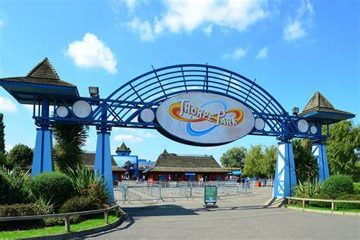

Surrounded by water, Thorpe park is an adventure ireland full of frills for the hole family. Take the kids on the Zodiac or the Rumba Rapids, and in the summer head to the beach and water park for a full day of aqua fun.

Want to test your own nerves? With some of the highest, fastest, steepest rides in the country, you can spend the day pushing yourself to the limit. Experiance the steepest freefall in the country or the only ride themed on a horror film. The newest highlight of the park is a truly mind-bending experience: Derren Browns Ghost Train, designed by the master of psychological manipulation himself, will have you questioning what you’re own mind is telling you.

1.

2.

3.

4.

5.

6.

7.

