October 2020

I am delighted that you are interested in the vacancy of teacher of modern foreign languages at Unity College. At Unity College, you will have every opportunity to develop your career and be part of a college that is totally committed to achieving outstanding results.

Unity College opened in September 2006 following the re-organisation of education in Burnley. I feel very privileged to hold the position of Headteacher at Unity College. I am passionate about education in Burnley and the governors and I are looking for a highly motivated and outstanding professional to work as part of our team to turn the vision for Unity College into reality.

The college was part of the Building Schools for the Future programme and we moved into our £33 million state of the art building in September 2010. The college has fantastic facilities and is an ideal learning environment for students and staff.

The intake at Unity College is challenging – 38% pupil premium, 11% of students registered as special needs, 6% Asian heritage, 94% White British and 21% of students on roll live in some of the most deprived wards in the country.

The challenges at Unity College are great, but so are the rewards. Working with myself, the governors and the staff at Unity College, you will have a once in a lifetime opportunity to make a difference to children’s life chances in Burnley.

In your letter of application can you explain how your experience to date has prepared you for this role (no more than two typed pages, minimum font size of 12).

I look forward to hearing from you.

Yours faithfully
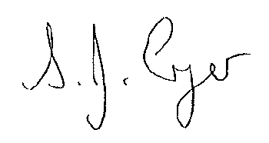
CLOSING DATE: MONDAY 19 OCTOBER 2020 at 9.00am
INTERVIEW DATE: TBC
S Cryer (Mrs)
Headteacher

Closing Date: TUESDAY 6 FEBRUARY 2018

Interview Date: TBC

Closing Date: TUESDAY 6 FEBRUARY 2018

Interview Date: TBC

Closing Date: TUESDAY 6 FEBRUARY 2018

Interview Date: TBC

The college is committed to safeguarding and promoting the welfare of its students and the appointment will be conditional upon DBS enhanced clearance.

