Remote Learning Guide

January 2021

Contents

- Remote learning during college closure (lockdown)...……………p.3
- The college day ……………………………………………………...p.4
- How to contact with us during college closure (lockdown) ……...p.5
- Covid19 related student absence when college is open…...…….p.6
- Help accessing online resources …………………………………..p.7
- Behaviour expectations online ……………………………………..p.14
- Half-termly overviews ……………………………………………….p.15

Unity College Remote Learning Provision
during College Closure due to Lockdown
In the event that the college is forced to close due to a national, regional or local lockdown, a full timetable of online learning will be provided by the college. The lessons and resources provided during this time will follow as closely as possible to the planned curriculum if college was open and students were attending.
Daily Provision for Students
All students are expected to follow their usual timetable for the full college day (8.50 am to 3.10pm). For further details of the timings of lessons and the college day, please see next page.
Most lessons will be presented live by the students’ class teacher (unless unavailable due to illness). These lessons will be presented through Microsoft Office 365 Teams meetings. Students are expected to join each lesson’s Teams meeting at the beginning of the lesson and a register will be taken of those present.
Once the register has been taken, students may be asked to complete work in a variety of ways, including: login to another online learning platform to complete work (e.g. Hegarty Maths); take part in class discussions and follow a power point delivered by the class teacher; receive instructions for the first part of the lesson and then work independently for the remainder of the lesson. In all of these scenarios, the class teacher will be available, for the duration of the lesson, to answer questions and give advice and support. If the usual class teacher is unable to attend due to illness, another member of staff will take the register and be available to provide help and support.
Teachers will set work daily via Satchel One (formerly Show my Homework).
Homework
When students are remote learning due to whole school closure (lockdown), we recognise that students will be spending a lot of time sitting down in front of computer screens. Therefore, weekly homework challenge tasks have been set by the House Leaders to encourage students to complete activities to promote health and wellbeing. Students can choose when and in which order they complete the tasks. Once completed, the tasks should be submitted to the appropriate year group homework folder on Teams.
Student Absence from Remote Learning Lessons due to Illness
If your child is unwell and unable to take part in lessons, please notify the college in the usual way. Attendance in lessons will be noted and monitored. If students miss a number of lessons, we will contact home to offer help and support.

The College Day
The structure of the college day:
Period | Time
1 | 8:50 – 9:40
2 | 9:40 – 10:30
Break/PD | 10:30 -10:50  10:50 – 11:10
3 | 11:10 – 12:00
4 & Lunch  (Students have half an hour for lunch break and one hour of the period 4 lesson) | 12:00 – 1:30
5 | 1:30 – 2:20
6 | 2:20 – 3:10

How to contact us:
Year Group | Email Address
Year 7 | m.cole@unity.lancs.sch.uk; r.boardman@unity.lancs.sch.uk; m.williams@unity.lancs.sch.uk;  l.doney@unity.lancs.sch.uk
Year 8 | m.cole@unity.lancs.sch.uk
Year 9 | m.williams@unity.lancs.sch.uk
Year 10 | r.boardman@unity.lancs.sch.uk
Year 11 | l.doney@unity.lancs.sch.uk

IT login help/ forgotten passwords for Office, Satchel One (Show My Homework) | loginhelp@unity.lancs.sch.uk
IT equipment queries (devices & wifi) | z.hammond-phillips@unity.lancs.sch.uk
Free School Meals | fsm@unity.lancs.sch.uk
Special Educational Needs assistance | v.smith@unity.lancs.sch.uk
Attendance | s.hudson@unity.lancs.sch.uk

Contact Details
Unity College
Towneley Holmes
Burnley
BB11 3DF
01282 683010
The college main reception is open from 8.20 am to 4.00 pm Monday to Friday.
Covid19 Related Student Absence
when College is Open
Below is a quick and easy reference guide so that you can easily identify the type of remote learning that will be provided by the college in the event of a Covid-19 related absence. There is also guidance on how the work will be delivered in different situations (i.e. online resources, pre-recorded streamed and live lessons).

Student Help Accessing Online Resources
Satchel One (Show My Homework)
Every morning we expect you to login to www.satchelone.com to check the work that has been set for you that day.
Use the calendar function to see the tasks you have been set for the day. Classwork will appear in red. When you click on the task, it will then give you a range of information about the task including websites to access, resources to download and will often invite you to join a live lesson via Teams.
Please access each set lesson following your normal daily timetable of lessons.
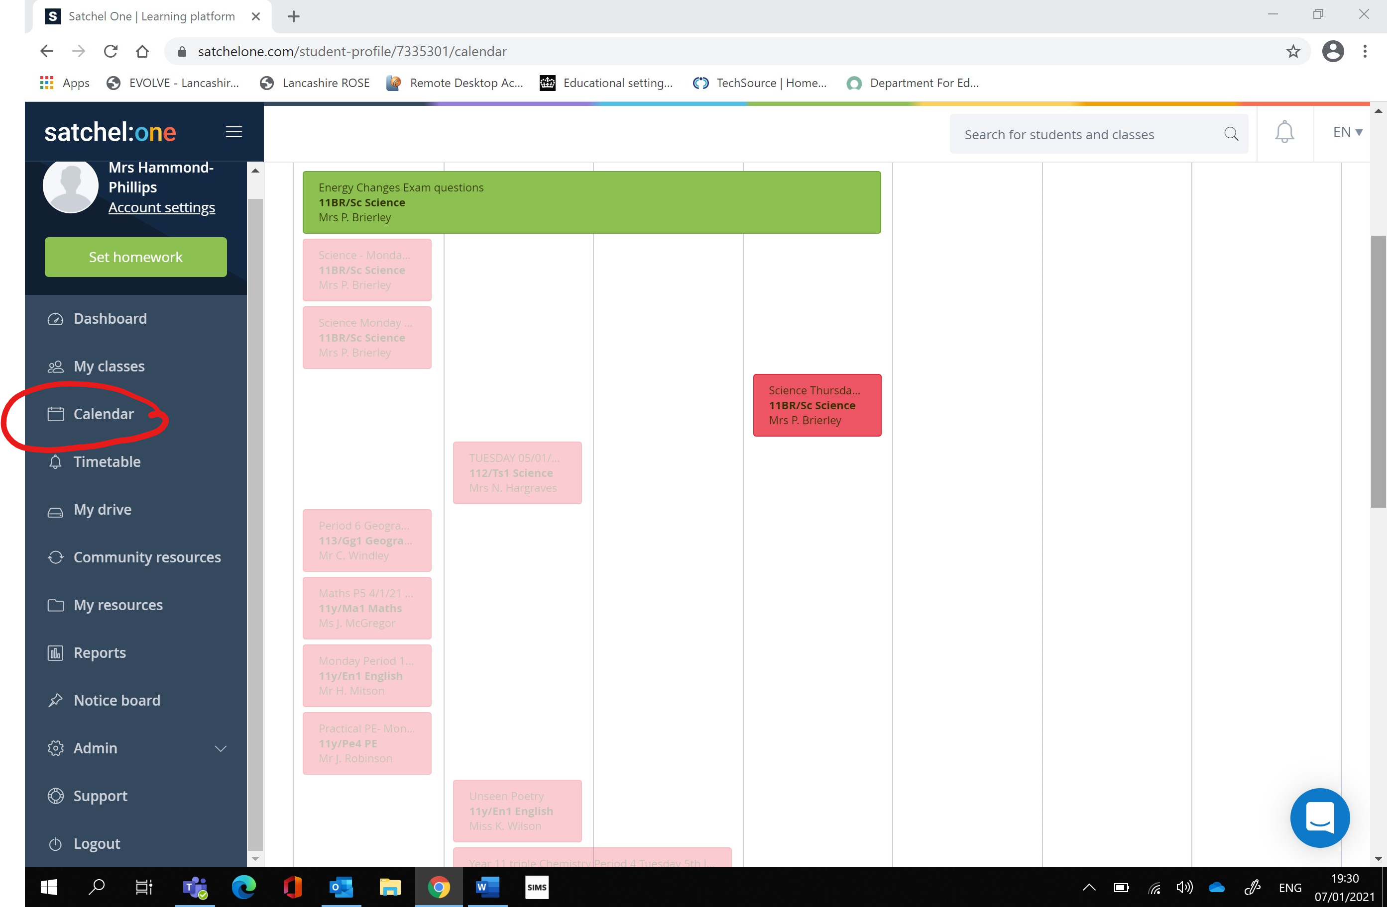

Office 365 - Teams
To access live lessons, you will need to login to Office 365 at www.office.com using your Unity College email address.
The format of this is: isurname16@unity.lancs.sch.uk (year 11)
isurname17@unity.lancs.sch.uk (year 10)
isurname18@unity.lancs.sch.uk (year 9)
isurname19@unity.lancs.sch.uk (year 8)
isurname20@unity.lancs.sch.uk (year 7)
Using this email address, you are more than welcome to email any member of staff about college work. Staff emails are in the following format: i.surname@unity.lancs.sch.uk . Please ensure that you only contact staff using your college email address.
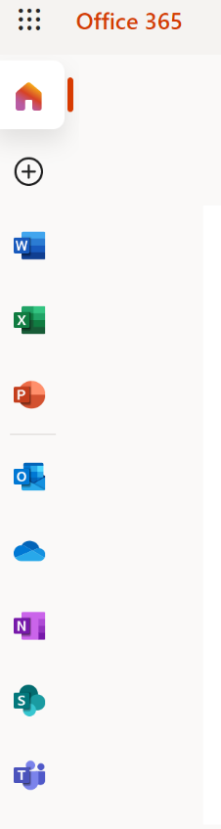
When you login to office.com you need to select Teams from the left hand side menu.
You also have access to the full range of office products for free using your college email address:
Word
Excel
Power point
Outlook (email)
One drive (where you have stored all your document)
One note
Sharepoint
Teams

When you select Teams, you need to access your live lesson meeting. Your teacher will have scheduled this for you. You can do this directly through the calendar or by accessing your class channel. You should access your Teams calendar every morning to ensure that you are present in any online lessons by 8.50am. You will only be able to access online lessons using your college Office365 email address.
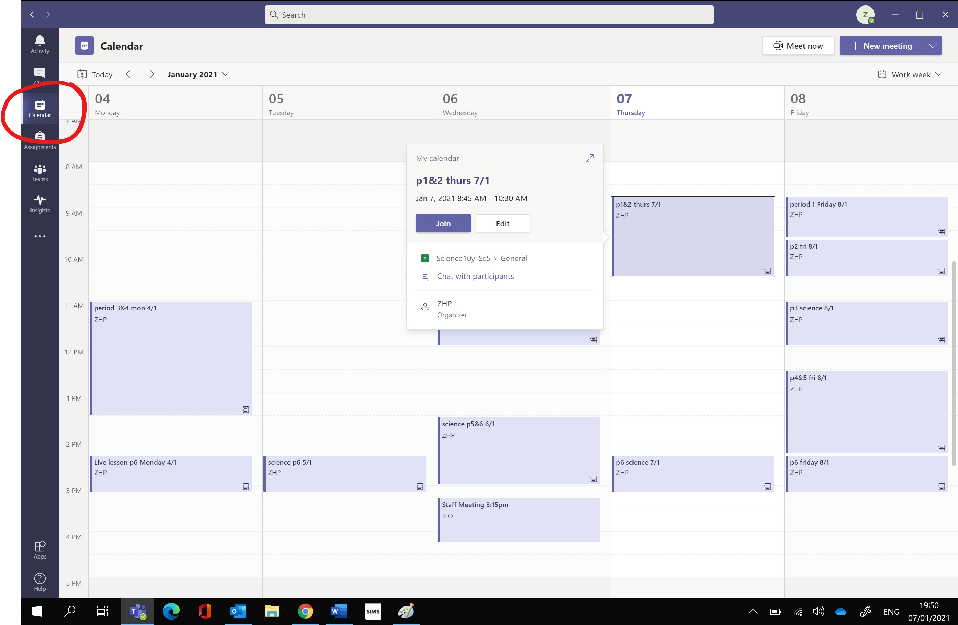

If you click on the meeting, then you will be given the option to join. You may need to wait in the lobby until your teacher lets you in.
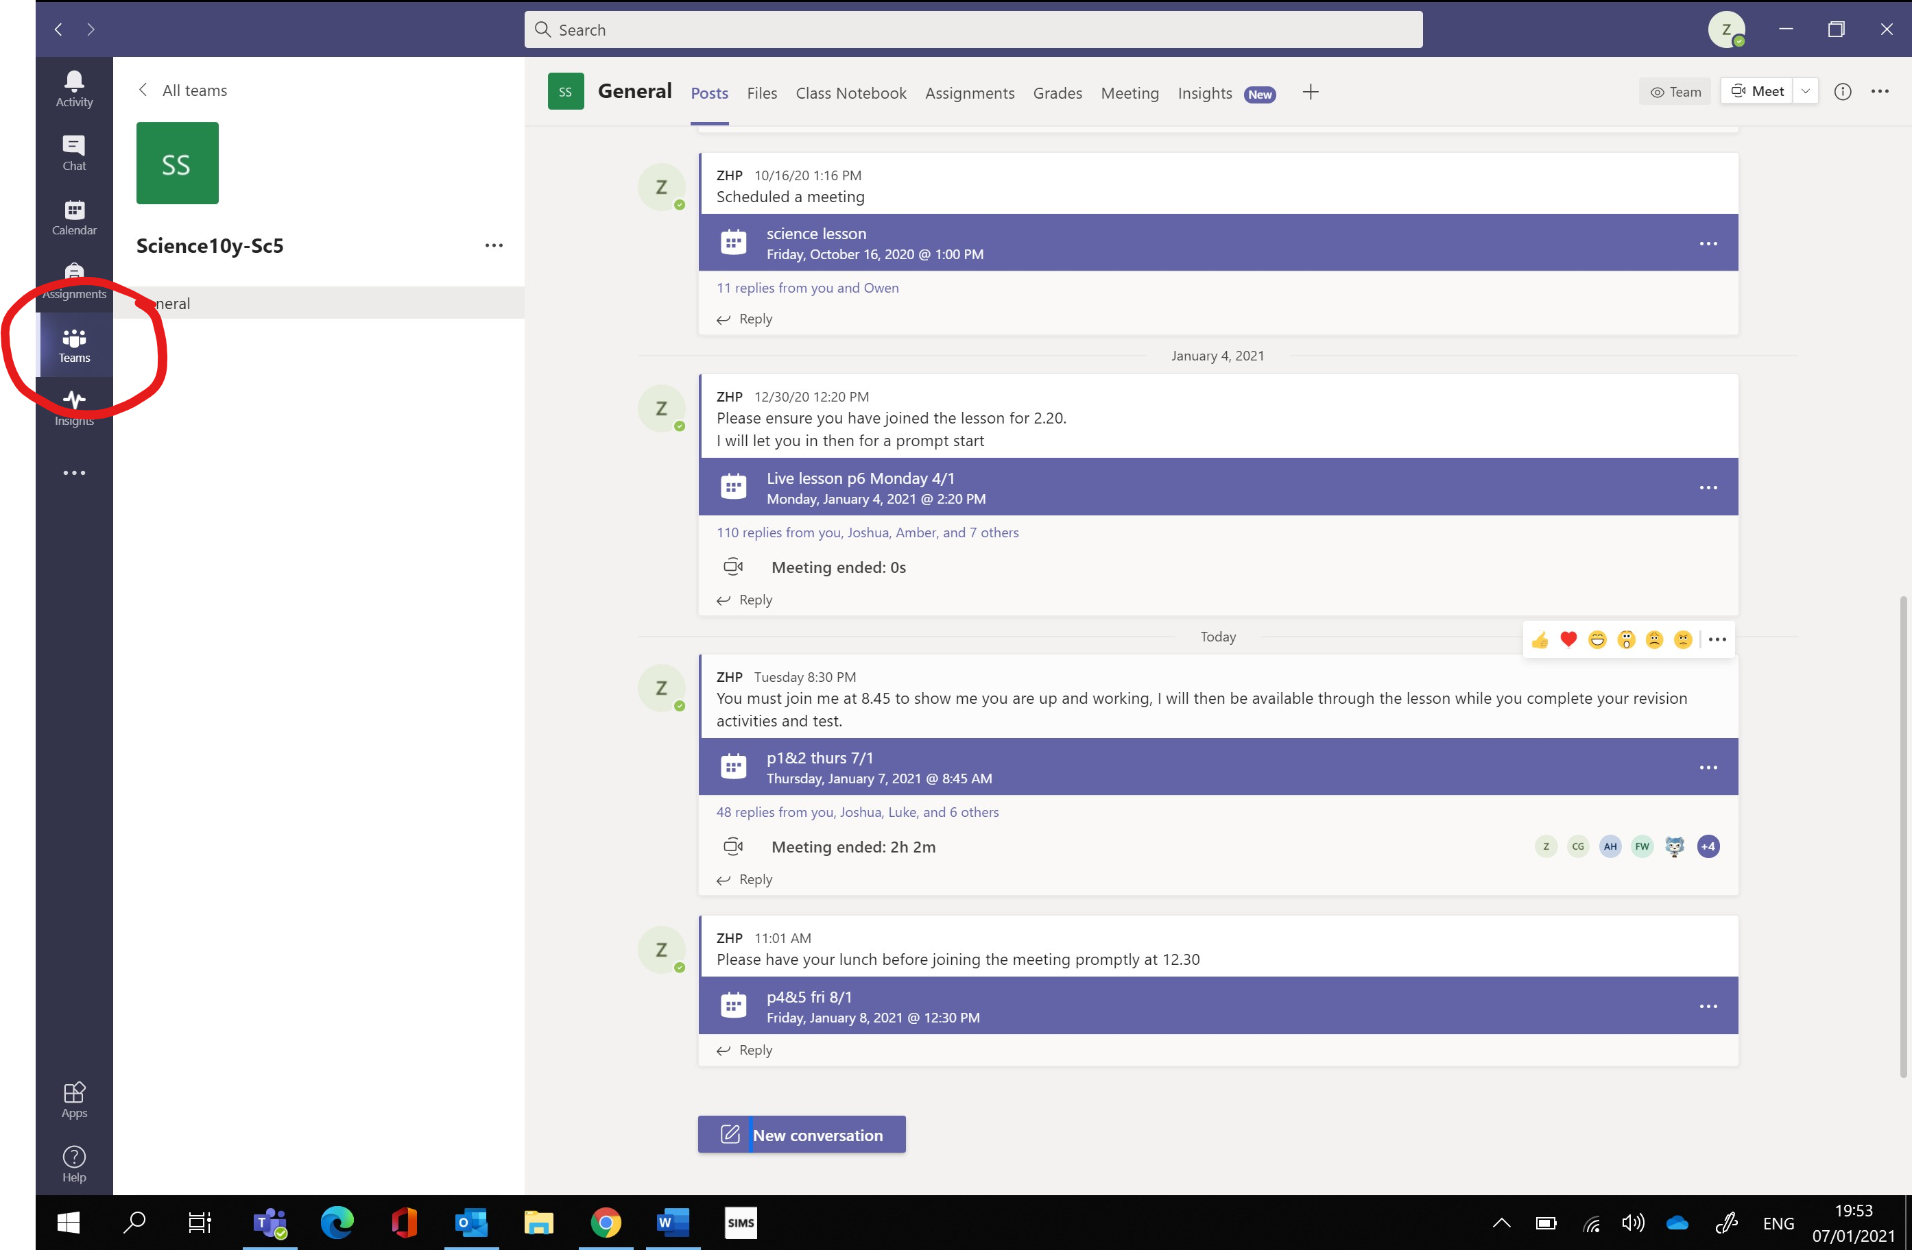
By selecting Teams, you can select the class. Here you will be able to access all previous meetings as well as the one you wish to attend that day.
Your teachers will use a range of online platforms to support your online learning. Details of logins to these programmes can be found by following this link https://unity-college.com/students/login-help2/ .
Should you forget any details of your login details please email loginhelp@unity.lancs.sch.uk with your full name, year group and then programme you need to have access to and a reset will be sent to you. Below is some guidance to accessing the most common online learning resources.

Hegarty Maths
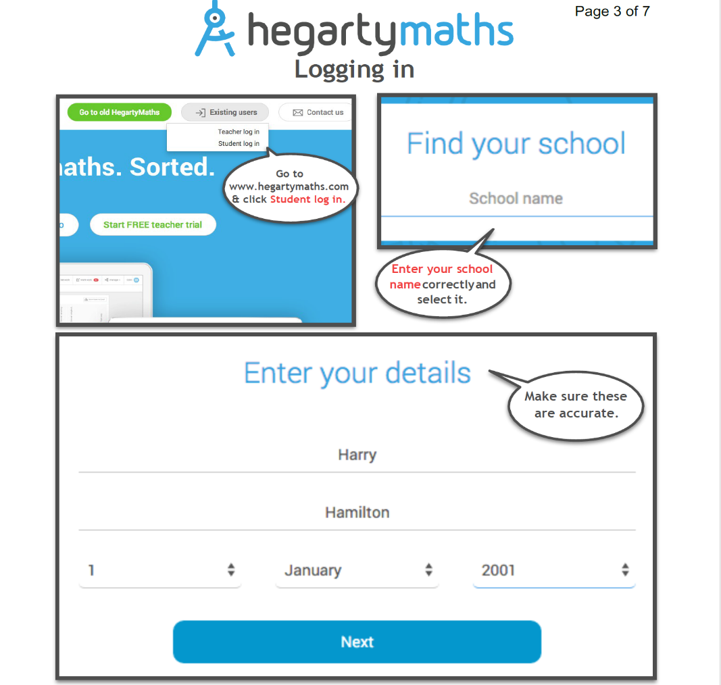

Kerboodle
Your login for Kerboodle is the same in all of your subjects.

- Search for ‘Kerboodle’ in your web browser and find the login page.
- Enter your user name. This is set as the first part of your Office 365 email address with no capital letters, e.g.
JBrownlowe17@ unity.lancs.sch.uk = Office 365 email
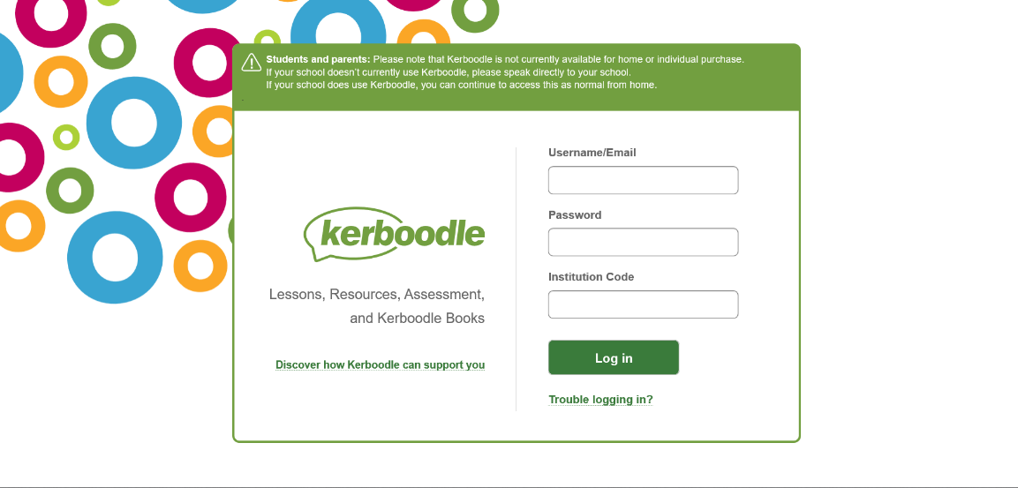
jbrownlowe17 = Kerboodle username

- Your password is exactly the same as your username, e.g.
jbrownlowe17 = Kerboodle password
- You then need to enter the Institution code for Unity College which is always: ry3
- Click on the text that you have been asked to use.

Seneca
Your login details for the Seneca site will be the same for every subject. If you have not used Seneca Learning for any other subject, please follow the instructions below:
- Search for ‘Seneca Learning’ in your web browser and find the login page.

- Click on the ‘Sign up’ tab in the top right-hand corner.
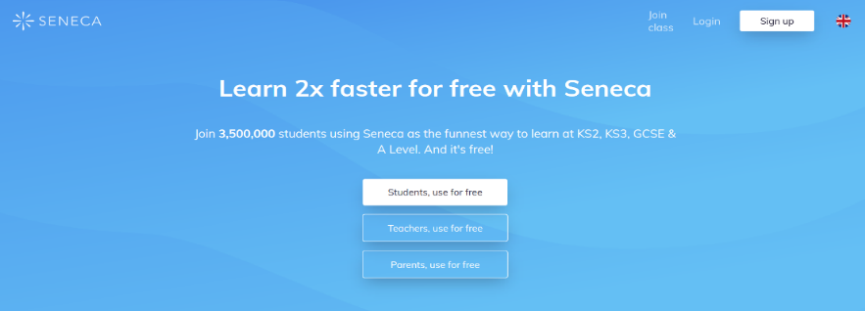

- Enter your first name, last name, Office365 email address and create a password (that you can remember – write it down somewhere safe if necessary). Click to agree to the terms & conditions.
- Then click on the ‘classes & assignments’ tab at the top.
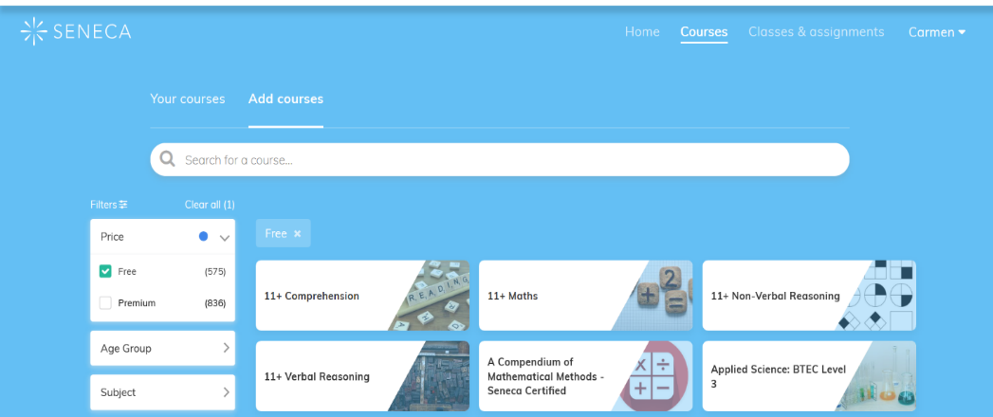

- Next click on the ‘Join class’ tab at the top of the page.
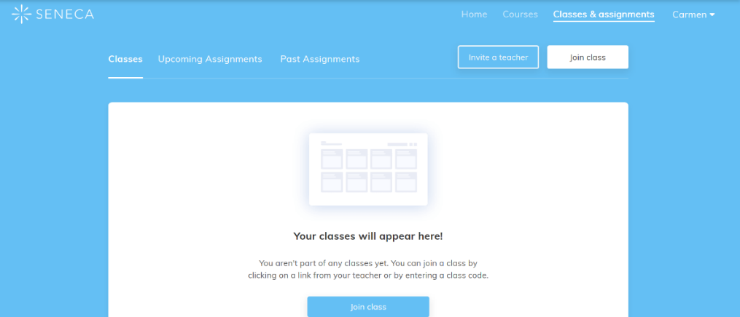

- Then enter the class code, that you have been given by your teacher, into the box that appears. If you are unsure of the code, contact your subject teacher who will be able to help.
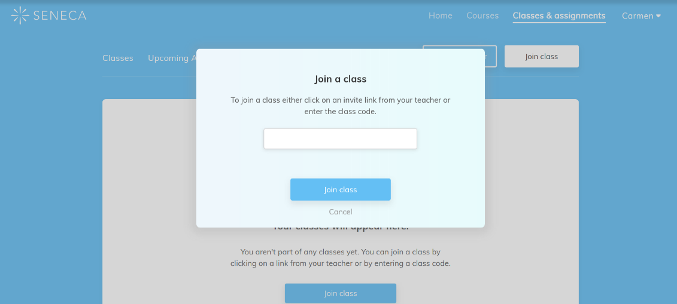

Login details for a range of other online resources and programmes can be found on Unity College website by following/ cutting and pasting this link: https://unity-college.com/students/login-help2/ .

Further Assistance
Should you need any further assistance with accessing or logging on to a particular online resource, please contact the relevant subject teacher directly.

If a username or password has been forgotten for Office365 or Satchel One (Show my Homework), please email:
logninhelp@unity.lancs.sch.uk

Teams Live Lessons
Students’ Guide to Behaviour Expectations
When actively engaged in remote Teams live lessons, the following code of conduct applies:
Before the lesson starts:
- Set up your device in a quiet environment and have all your equipment ready for the lesson.
- You will only be allowed to join the live lesson, if you are using your Unity College email account.
- Be prepared to log on to your ‘Teams’ live lesson promptly at the start of the lesson to avoid last-minute delays and/or to address technical issues (you will not be able to access the classroom until your teacher is present).
- Once you enter the meeting please mute your microphone.
- Minimise distractions as much as possible by ensuring that your mobile phone is turned off or is in another room, where it will not divide your attention. If you have any siblings or pets, try to ensure that they do not cause any disruption to your or your class.
What the teacher expects during the lesson:
- Your microphone should be muted for the duration of the lesson unless the teacher asks you to make a spoken contribution.
- You must only use the Chat or Share functions for work related questions and registration. Students using these functions for social purposes will be issued a warning.
- Please remember you are accountable for what you say on your microphone or in writing (just like in school). Making inappropriate, offensive or unkind comments, including through emoji’s and/or images will not be tolerated. Any inappropriate behaviour will be dealt with in line the Unity College’s behaviour policy.
- The recording of still images, filmed images or audio of staff or other students without permission, and the distribution of such recordings, is strictly forbidden and will be treated as a serious breach of college’s behaviour policy.
- Behaviour, when working as part of an online lesson should be as expected in a normal classroom setting.

Consequences for failing to meet behaviour expectations
- Students, who fail to adhere to the above guidance or who do not meet the College’s high behaviour expectations in live lessons, will be issued with a warning. The teacher will explain why the warning has been issued and record it.
- If a student receives a second warning, they will be removed from the live lesson. Students who are removed from the lessons should never attempt to re-enter a live lesson. A consequence will be recorded and parents may be contacted.

Half Termly Overviews
The purpose of these overviews is to provide curriculum support for you and your child. They give an overview of topics studied with useful links to teaching resources both online and hard copies. However, these are subject to review at any time particularly under the current circumstances of Covid19.
Please follow or cut and paste the link below to access the Half Termly Overviews for all subjects and year groups:
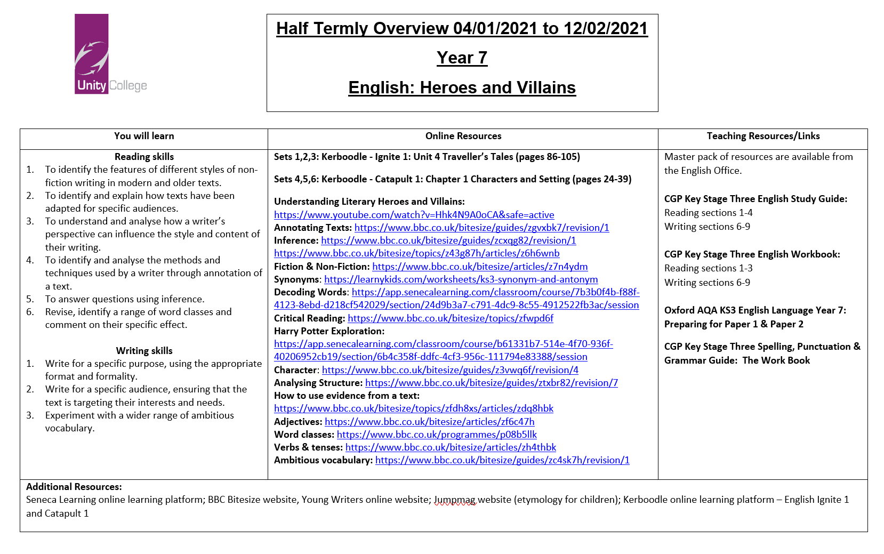
Half Termly Overviews - Unity College (unity-college.com)

