Ideas to support your leavers and their families.

Date, time, type | Provider and activity | Notes and how to access
On demand  2m video | Department for Education Post-16 Choices Animation | https://www.youtube.com/watch?v=f_xAQNNi4pA&t=56s
The programmes will go live on these dates but available on demand afterwards  13th May  20th May  27th May  10th June  17th June  26th June | AHEAD OF THE GAME  Careers and Enterprise Company plus Youth Employment UK  An excellent resource to support young people over this period is the Young Professional - a fantastic free resource from Youth Employment UK (YEUK).  Within each programme there are a number of short individual courses that upon completion issues the Young Professional with a certificate.  This joint campaign with YEUK, will centre around six weeks of activity for young people that you can adapt in terms of timing and delivery to suit your setting and cohorts:  Week 1 You and your needs Week 2 Knowing your choices Week 3 Building your life skills  Week 4 Getting experience of work and building networks Week 5 Choosing and finding a career for you Week 6 Getting and staying ahead of the game | https://www.youthemployment.org.uk/employment-help-young-people/choices/online-skills-and-careers-courses/preparing-for-your-future-online-course/  We would encourage you to explore school sign up for whole cohorts of Year 11 students particularly, but this is also something that students can access from home independently and we would encourage you to share this with parents and carers too.  Sign up to the Young Professional Group Management System at no cost, which provides support for group registration and group reports to see, and evidence progress of participants.
Free, accessible platform.  Use when needed | Start in Lancashire | https://lancashire.startprofile.com/page/home-page  Everything a student and their families need to explore, find the information, take them on a journey to make decisions  Students can self register or you can bulk onboard the whole school  - Register your school/students on Start in Lancashire. Go to https://lancashire.startprofile.com/page/home-page - register - look for the welcome email – log on – Use management – follow the written or video instructions on exporting from SIMS
Live  6th May  13th may  20th May  27th May  10th June  17th June  24th June  1st July | ASK  Apprenticeship sector workshops.  Attendance to be facilitated by schools for safeguarding.  An amazing opportunity to get advice from industry experts, employers and apprentices in the sector, ask questions, search for apprenticeship vacancies through the ‘Find An Apprenticeship –FAA’ service and connect directly with apprenticeship providers in Lancashire. | For more information and to book on to the event(s) in your Lancashire region please contact cath@lancsforum.co.uk or on 07495 051789  Hospitality & Leisure - Thursday 6 May 1 –3pm  IT & Digital – Thursday 13 May 1 –3pm  Engineering & Manufacturing – Thursday 20 May 1 –3pm  Agriculture & Land-based Services – Thurs 27 May 1 –3pm  Business & Customer Service – Thurs 10 June 1 –3pm  Health, Social Care & Education – Thurs 17 June 1 –3pm  Sports & Recreation – Thursday 24 June 1 –3pm  Construction & Building Industries – Thurs 1 July 1 –3pm
27 May onwards.  Entrance is available to the virtual fair | Lancashire’s Virtual Careers Expo powered by vFairs  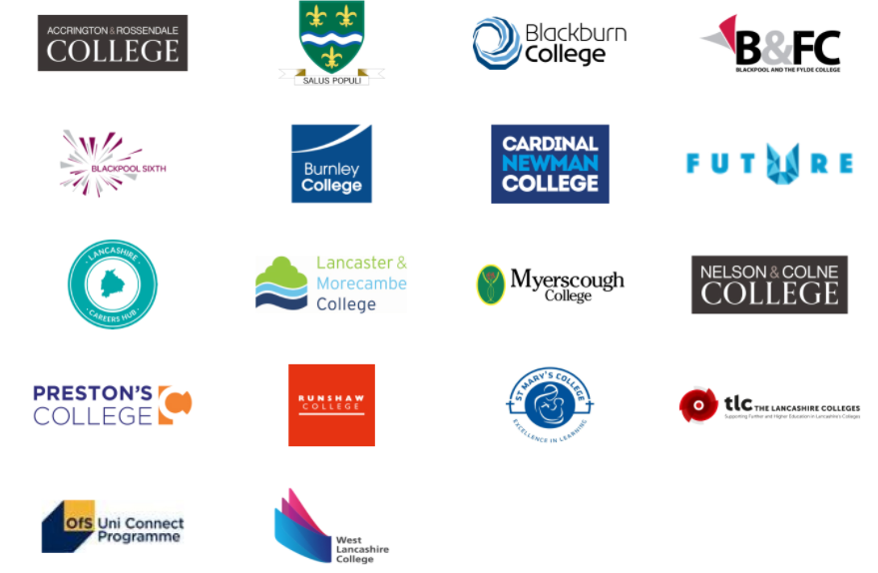 | https://inspiringyourfuture.vfairs.com/  Inspiring Your Future event via this virtual expo. Alongside inspiring, careers-based talks you can visit the booths of 40 Lancashire employers and providers with insights, future opportunities and ideas to set your goals.  Fill your virtual goody bag!
2 June  Application deadline 14 May | Virtual work insights  Keepmoat Homes - Construction  Via Speakers for Schools | https://www.s4snextgen.org/Opportunities/View/id/1439  Delivered by real life professional, so they can give advice and guidance and share their own experience of working in the industry.  Live and pre-recorded sessions  Learn more about construction and the Housebuilding sector  Get an overview of jobs available in the construction sector and Housebuilding  Learn about different stages of house building  Learn from real life professionals working in the sector and hear about their journey  Work with other students on a fun and engaging group house building challenge  Develop your employability skills  Pitch, and present your project Dragon’s Den style
June 2  9.45 to 15.00 | Virtual work insights  Health Education England (via Pathway CTM)  Health and Social Care sector  350+ careers | https://www.eventbrite.co.uk/e/virtual-taster-day-work-for-the-nhs-tickets-149729678499  Gain insight into the various routes into the NHS and what a day in the life of NHS employees entails.  There are over 350 potential careers in the NHS and one of them could be yours
10 June | Virtual work insights and opportunities  Telent – Careers in Rail live event | The session will introduce Telent’s careers in Rail and discuss the many roles which contribute to making the network run smoothly (most don’t take place near a railway). You’ll hear from Telent’s Graduates and Apprentices and senior colleagues that started their careers with our early careers programmes. You’ll see the behind-the-scenes technology which Telent provides.  https://forms.office.com/pages/responsepage.aspx?id=IcpW7_pjv0ep2rsbjPN49tY9eWCWbClAjofNoweBEo9UMkxPV0tNOEtTRDdIQTVaT0pGOTRaNjgyNy4u
Every Thursday at 10am through the rest of the year | Virtual work insights  Balfour Beatty – Construction | https://learnliveuk.com/partner/balfour-beatty-careers/  https://jobsliveuk.com/partner/balfour-beatty-careers/  We will interview different people from the construction industry to find out about their career path and the options available to young people to enter a similar career path. Live, interactive chat throughout the session.
17 and 18 June  Application deadline 28/05/2021 | Virtual work experience  Liverpool John Moores University- Digital  (Speakers for Schools) | https://www.s4snextgen.org/Opportunities/View/id/1438  Hear from professionals across the engineering & technology sector, CNC Robotics is a pioneering the use of robots as an alternative to traditional machine tools; Beverston Engineering manufacture high precision safety critical components for the aerospace, pharmaceutical, oil & gas industries; Scenegraph Studios, a creative immersive experience development company, specialising in software development, VR & AR; Maritime
Live  22 June  5.30 to 6.30 | Lancashire Learnlive  Post 16 pathways. Young people sharing their experiences of all routes beyond school | https://learnliveuk.com/partner/lancashire-local-enterprise-partnership/  The timings are to encourage parents and careers to watch too. Look out for the schedule to be published on this page.
5th to 9th July  Online application form plus virtual workshop to prepare for the final stage, an online test | Virtual work experience  BDO - Summer Programmes  (one of the UK’s largest accountancy and business advisory firms) | https://www.bdoearlyincareer.co.uk/about-bdo/  A week-long virtual insight experience students will learn more about BDO, develop their professional skills and meet a wide range of people from the business.
23 June  Application deadline 31 May | Virtual work insights  Electricity North West via Speakers for Schools | https://www.s4snextgen.org/Opportunities/View/id/1516  Learn about life at Electricity North West, the wide ranging roles and life as an apprentice. Learn about different roles within the business, learn from our apprentices about their apprentice programme and the behaviors expected to thrive in work. Opportunity to undertake an activity to understand more about the future of the industry and the massive changes ahead.
23 June  2.30 - 4.00pm  Application deadline 31 May | Virtual work insights  Apprenticeships in the Food Industry with Kepak via Speakers for Schools | https://www.s4snextgen.org/Opportunities/View/id/1468  Kepak is a family-owned, future-facing food company with a rich heritage of more than 50 years of meat craft in Kirkham. Food innovators and pioneers of the micro-snack industry, we produce some of the nation’s favourite convenience foods: Rustlers and Feasters. Now, we are looking for new talent to lead our company into the future. We have opportunities ranging
7 July  Application deadline 11 June | Technology Insight Day with Lancashire Teaching Hospitals  Via Speakers for Schools | https://www.s4snextgen.org/Opportunities/View/id/1520  The variety of technology roles within the NHS and a project!  An introduction to technology within Lancashire Teaching Hospitals  Hearing from professionals who use technology as part of their daily job  An opportunity to take part in a digital transformation project where you will work in small groups to improve a current process
Various | Virtual work experience  Willmott Dixon Interiors | https://www.willmottdixon.co.uk/earlycareers/work-experience  Apply for work experience by uploading a CV and application
Various | Virtual work experience  The Lawyer Portal | https://www.thelawyerportal.com/free-guides/law-work-experience/virtual-work-experience-for-law-students/  A list of law firms offering virtual work experience. Further investigation would be needed to match dates/requirements etc.
All year | Virtual work insights  British Airways - Aviation | https://britishairways.connectr.co.uk/inspire/modules  Online modules with the opportunity to contact BA mentors
All year | Virtual work insights  Hunter Bevan - Design and marketing | https://hunterbevan.co.uk/missing-out-on-work-experience-this-year/  2 tasks to choose. Feedback will be given to tasks completed plus a chance to feature on Hunter Bevan's website.
All year round. No deadline  7-9 hours to complete | Virtual work insights  Brighton and Sussex Medical School | https://bsmsoutreach.thinkific.com/courses/VWE  Online guided modules with feedback
All year | Virtual work insights  Halliday Fraser Munro - Architecture and design | https://workexperience.hfm.co.uk/  2 sets of work experience tasks – Design and Technical. Skills of understanding spatial modelling and a design brief. Platform to upload the work.
On demand  Approx. 60 mins in total | Careers and Enterprise Company / Oak Academy  My Week of Work: Monday  An introduction to My Week of Work and the sector options for students to explore: creative digital, engineering, construction, energy and renewables and health and social care. The final session of the day gives an insight into the world of work. | 4 videos with inbuilt explanations and instructions. They provide insights and ask students to reflect before selecting sectors to focus on.  https://resources.careersandenterprise.co.uk/resources/my-week-work-monday
On demand  Approx. 60 mins in total | Careers and Enterprise Company / Oak Academy  My Week of Work: Tuesday  Introducing the world of Human Resources. These lessons cover work/life balance, dealing with stress at work and self-reflection, considering which careers options would suit you. | 4 videos with inbuilt explanations and instructions. They provide insights and ask students to undertake sector specific tasks.  https://resources.careersandenterprise.co.uk/resources/my-week-work-tuesday
On demand  Approx. 40 mins in total | Careers and Enterprise Company / Oak Academy  My Week of Work: Wednesday  Introducing the world of Marketing. These lessons cover innovative thinking, creativity, marketing campaigns and promoting yourself as a brand. | 4 videos with inbuilt explanations and instructions. They provide insights and ask students to undertake sector specific tasks.  https://resources.careersandenterprise.co.uk/resources/my-week-work-wednesday
On demand  Approx. 45 mins in total | Careers and Enterprise Company / Oak Academy  My Week of Work: Thursday  Introducing the world of Recruitment. These lessons cover the skills employers look for, how businesses recruit, entrepreneurship and project planning skills. | 4 videos with inbuilt explanations and instructions. They provide insights and ask students to undertake sector specific tasks.  https://resources.careersandenterprise.co.uk/resources/my-week-work-thursday
On demand  Approx. 40 mins in total | Careers and Enterprise Company / Oak Academy  My Week of Work: Friday  These lessons explore what it means to be an effective leader, how to create an impactful CV and recognise and demonstrate employability skills. The week is completed with some reflection – what could be your next steps and how to prepare for discussions with a careers adviser. | 4 videos with inbuilt explanations and instructions. They provide insights and ask students to reflect before advising on next steps  https://resources.careersandenterprise.co.uk/resources/my-week-work-friday
On demand | Careers and Enterprise Company / Learnlive  - Being Prepared and Adding Value  - Considering apprenticeships or employment?  - Tips for CV writing, applications, interviews and selection processes.  - Employability skills, what they are, how to demonstrate and build them through work experience, volunteering and Youth Social Action.  - Decision Making and Finding Support | A range of short, informative videos to browse  https://learnliveuk.com/the-careers-enterprise-company-my-choices/

