June 2021

I am delighted that you are interested in the vacancy of teaching assistant 3 at Unity College. The post is for up to 30 hours per week with effect from 1 September 2021. At Unity College, you will have every opportunity to develop your career and be part of a college that is totally committed to achieving outstanding results.

Unity College opened in September 2006 following the re-organisation of education in Burnley. I feel very privileged to hold the position of Headteacher at Unity College. I am passionate about education in Burnley and the governors and I are looking for a highly motivated and outstanding professional to work as part of our team to turn the vision for Unity College into reality.

The college was part of the Building Schools for the Future programme and we moved into our £33 million state of the art building in September 2010. The college has fantastic facilities and is an ideal learning environment for students and staff. Unity College was judged as “Good” by Ofsted in November 2018 and we are on a journey towards “Outstanding”. By summer 2022 a new 19 classroom expansion will be completed which will enable us to increase our student number from 1250 to 1500 in the coming years.

Working with myself, the governors and the staff at Unity College, you will have a once in a lifetime opportunity to make a difference to children’s life chances in Burnley.

I look forward to hearing from you.

Yours faithfully
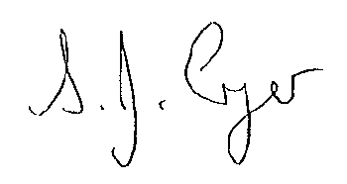
CLOSING DATE: 9.00AM WEDNESDAY 30 JUNE 2021
INTERVIEW DATE: TBC
S Cryer (Mrs)
Headteacher

Closing Date: TUESDAY 6 FEBRUARY 2018

Interview Date: TBC

Closing Date: TUESDAY 6 FEBRUARY 2018

Interview Date: TBC

Closing Date: TUESDAY 6 FEBRUARY 2018

Interview Date: TBC

The college is committed to safeguarding and promoting the welfare of its students and the appointment will be conditional upon DBS enhanced clearance.

