FSM & PP Form – revised June 2019
Please complete this form online on the LCC website at:
https://www.lancashire.gov.uk/children-education-families/schools/free-school-meals
If you have no access to the internet and you believe your child may be entitled to free school meals, please complete this form and return to College so that we can forward it to Pupil Access.
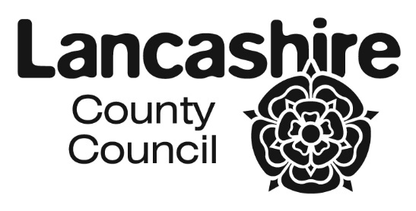

FREE SCHOOL MEALS AND PUPIL PREMIUM
We need information about you and your child so that we can provide them with the best education and support, by making sure that their school receives all the government funding to which it is entitled.

Please complete all sections of the form and return this to the school

Free Schools Meals & Pupil Premium Eligibility Criteria:
Please indicate which benefit you are currently in receipt of:
Universal Credit with a household income of less than £7,400 a year (after tax and not including any benefits you get)
Income-Based Jobseekers' Allowance
Income-Related Employment and Support Allowance
Child Tax Credit, not entitled to Working Tax Credit and household income less than £16,190
Support under part VI of the Immigration and Asylum Act 1999
Guarantee element of State Pension Credit
Income Support
Working Tax Credit 'run on' – the payment you receive for a further four weeks after you finish work
Applicants in receipt of the above benefits or credits may be required to enclose proof. You will be contacted should further information be needed.

Please ONLY complete the form overleaf if you have ticked one of the boxes above

CONTACT DETAILS FOR PUPIL ACCESS TEAM AREA EDUCATION OFFICES
NORTH AREA  Lancaster, Wyre & The Fylde | SOUTH AREA  Preston, South Ribble,  West Lancashire & Chorley | EAST AREA  Burnley, Hyndburn / Ribble Valley,  Pendle, Rossendale
Area Education Office  White Cross Neighbourhood Centre  Quarry Road  Lancaster  LA1 3SE  (01524) 581207 | Pupil Access Team South  Room C37  County Hall  Preston  PR1 0LD  (01772) 532109 | Area Education Office  44 Union Street  Accrington  BB5 1PL  01254 220747
Lancashire County Council - DfE Free School Meals Eligibility Checker
By sharing your information with us, you agree to the LA accessing the DfE Eligibility checker on your behalf.
Data Protection Act 2018 and General Data Protection Regulation 2018 (GDPR)
The Data Protection Act 2018 and GDPR are laws that are designed to protect and maintain personal identifiable information. When we are in possession of personal information we will protect it and aim to keep service user information safe, abide by the law in respect of handling personally identifiable information, and respect the wishes of service users who do not want us to share their information. Unidentifiable service user data may also be used to aid service development. Lancashire County Council holds personal data about the people/children to whom we provide services. There is more information about your rights and how the Council uses and stores data: http://www.lancashire.gov.uk/data-protection. To request a copy of the information we hold about you, contact The County Council's Data Protection Officer, PO Box 78, County Hall, Preston PR1 8XJ

- PARENT / GUARDIAN DETAILS – these should be the details relating to the person who is claiming the benefits and where the pupil resides.

 | Parent / Guardian 1 |  |  |  |  |  |  |  |  |  |  | Parent / Guardian 2
Title
First name
Last name
Date of birth |  |  |  |  |  |  |  |  |  |  |  | DD |  |  | MM |  |  |  | YYYY
Relationship to pupil
National Insurance Number*
National Asylum Support Service (NASS) Number* |  |  | / |  |  | / |  |  |  |  |  |  |  | / |  |  |  | /
Daytime telephone number
Email address
 | Parent / Guardian 1 |  |  |  |  |  |  |  |  |  |  | Parent / Guardian 2
Address |  |  |  |  |  |  |  |  |  |  |  | Postcode:
Previous address if you have moved in the last year | Postcode: |  |  |  |  |  |  |  |  |  |  | Postcode:

*Complete as appropriate

2. CHILD / CHILDREN DETAILS
Child's last name | Child's first name | Date of birth | Male / Female | Name of school attending | Year Group

DECLARATION
The information I have given on this form is complete and accurate. I understand that my personal information is held securely and will be used only for local authority purposes. I agree to LCC checking my details with relevant Government Departments or other agencies to assess my initial and ongoing entitlement to Free School Meals, Free Travel to School and Free School Milk. I also agree to notify the local authority in writing of any change in my family's financial circumstances as set out in this form.

Signature of parent / guardian:
Date:

FOR OFFICIAL USE ONLY
Outcome |  | Checked by
Date |  | Household ID

