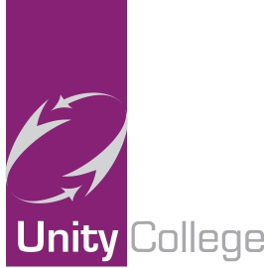
Unity College

Our Vision

Unity College is on a journey of transformational change.
Unity College will be judged as outstanding by all stakeholders and Ofsted.
Unity College will exceed national standards for progress, attainment and attendance and give the young people of Burnley the life chances they so thoroughly deserve. Our college will be the college of choice in Burnley and we will be oversubscribed on first preferences.
The college curriculum will provide our learners with unique opportunities that challenge, motivate, inspire and empower them and secure their future economic well-being.
We will produce a generation of well qualified, responsible adults who are ready to take their place in society with the knowledge, skills and understanding to become life-long learners prepared for life in the 21st Century.
Our focus on academic achievement and the social, moral, spiritual and cultural development of our learners will mean that we offer an unrivalled quality of provision and provide excellent value for money.
We will continually and rigorously evaluate ourselves with openness, honesty and trust; balancing the desire to highlight any barriers to learning facing the college with the need to challenge and seek the highest standards and levels of progress possible.
The college’s ethos of “Unity, Passion and Respect” will permeate through all aspects of the college and staff and students will strive to be “the best that they can be.”
In order to achieve our vision we have a Towards Outstanding Plan with four clear priorities:

ATTAINMENT AND PROGRESS
Continue to accelerate the rate of student progress and improve outcomes for ALL students.

QUALITY OF TEACHING
Further improve the quality of teaching so that ALL is at least GOOD and most is OUTSTANDING.

LITERACY AND ORACY
Students will read well, widely and often in order to develop a love of reading. Students will express themselves confidently, fluently and grammatically in speech and writing, providing a strong foundation for their learning.

CONTINUOUS IMPROVEMENT
To continue to monitor, evaluate and further improve the quality of provision and education for ALL students.

May 2022

