May 2022

Dear Parent/Carer,

Unity College is committed to raising achievement through music and offering high quality instrumental tuition to students. We are proud to work in partnership with specialist teachers to offer instrumental and vocal lessons to promote music by professional musicals who also work in the music industry.

We are able to offer 20 minute group lessons with 2 students in a group and individual 20 minute lessons. The following costs apply for lessons:

 | Singing | Instrumental
Individual | £12.50 per lesson | £11 per lesson
Group | £7.50 per lesson | £6 per lesson

These lessons are excellent value for money, and cheaper than you will find in most places. Once you are signed up and have activated your ParentPay account, the lessons will be added there and you will need to make the payment for the lessons half termly in advance. If you would like your child to start lessons in September the payment will need to be made by Wednesday 31 August 2022.

We also have a small number of instruments that are available for hire. If you do choose to buy your own instrument, we are pleased to be able to offer the government ‘Assisted Instrument Purchase Scheme’, where you can buy your instrument through College without having to pay VAT.

If you have any questions about instrumental or vocal lessons, please do not hesitate to contact me via email – music@unity.lancs.sch.uk

If you would like to go ahead and sign your child up for lessons, please complete the form on the next page. Each teacher will have slightly different terms of business and these will be sent out to you on the receipt of your form. If you are not happy with the terms of business a full refund will be given.

Yours faithfully,

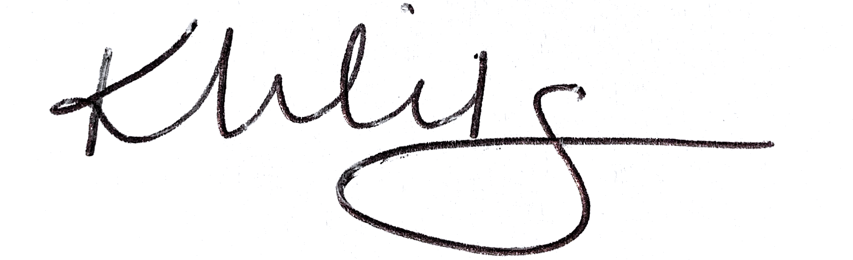

Ms K Wilson
Head of Music

Instrumental and Vocal Lessons Sign Up

Student Name: ________________________________________________________________________

Instrument Choice:

 Voice  Guitar
 Piano  Drum Kit
 Other (please specify) _________________________________________________________________

Lesson Type:

 Group  Individual

Instrument Loan: Do you require an instrument loan from college? We cannot always guarantee these are available and will be offered on a first come, first served basis.

 Yes  No

Experience: Please outline any experience your child has on their chosen instrument.

_____________________________________________________________________________________

_____________________________________________________________________________________

_____________________________________________________________________________________

Signed: _________________________________________________ Date: ______________________

