Transition Workbook
Year 6 to Year 7

Unity College Maths Department

sparxmaths.com

In this booklet, there are a range of questions from key topics that you will have seen in year 6 and will be helpful for the start of year 7.
Page 2

Each topic has three sections:
- Introduce questions are warm-up questions to practise the basics.
- Strengthen questions build your knowledge in key concepts.
- Deepen questions are more challenging reasoning and problem-solving questions.

Use the grid below to keep track of your progress in each topic. Tick the sections you have attempted.

Introduce Strengthen Deepen Teacher comment

Place value Negative numbers Rounding
Adding Subtracting Multiplying Dividing Fractions 1
Fractions 2

Factors and prime numbers

Area and perimeter Ratio relationships

Place value Introduce

Q1 Which one of these numbers has 4 tens?

543, 534, 435, 4563

Answer:

Q2 Write four hundred and six in figures.

Answer:

Q3 Write down these numbers in order of size, starting with the smallest: 3.8, 3.6, 3.9, 3.5, 3.4

Answer:

Q4 In which two of these numbers does the digit 7 have a value of 0.7?

57.2 23.71 64.17 79.24 17.56 14.78

Answer: and

Page 3

Place value Strengthen

Q1 Which of these numbers shows five thousand and eight?

58 500,008 508

5008 50,008

Answer:

Q2 Arrange these numbers in ascending order (from smallest to largest): 4.46, 9, 8.8, 1.5, 6.06, 4.21

Answer:

Q3 Which of these numbers is closest to 1?

0.9404 | 0.907 | 0.94
0.9005 | 0.9306 | 0.9408

Answer:

Q4 Arrange the number cards in the place value grid to make the largest possible number.

3 5
9

Answer:

Ones 1

Tenths
1 10

.

Hundreths
1
100

Page 4

Place value Deepen

Q1 Work out the number that should go in the box to complete the sum.

8000 +

+ 5 = 8065

Q2 Write down the number two million and thirty in figures.

Answer:

Q3 Using these cards, what is the closest number to 320 that you can make?
You must use all the cards and use each card only once.

5 2 7 3 .

Answer:

Q4 Arrange all three number cards below to create the largest even three-digit number.

5 8 7

Answer:

Page 5

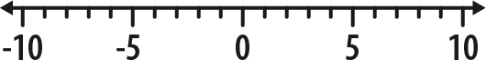
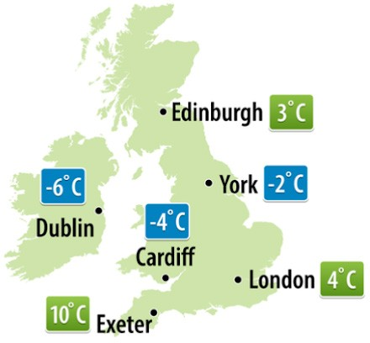
Negative numbers Introduce

Q1 What numbers should replace A, B, C and D on the number line?

5

A -3
-5
B -1 0
C D 3 4

Answer: A: B: C: D:

Q2 What number is the arrow pointing to on this scale?

-10 0

Answer:

Q3 The weather map shows the temperature recorded one night last winter.
Which city had the lowest temperature?

Answer:

Q4 Which is higher,

- -4 or 1?

b) -6 or -2?

a)
Answer:
b)

Page 6

Negative numbers Strengthen

Q1 Find the temperature that is 9ºC lower than 4ºC.

Answer: ºC

Q2 Write these temperatures in order, starting with the coldest: 9ºC, -8ºC, 3ºC, -10ºC, 0ºC, 7ºC

Answer:

Q3 Write these numbers in ascending order (lowest to highest).

77, -17, -770, 700, 7, 70

Answer:

Q4 Write < or > in the empty boxes below to make the statements correct.

3 -7
-2 -8
-6 -4

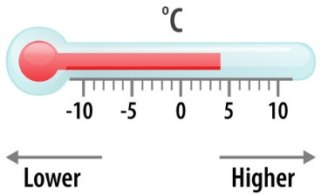

Q5 Write down these numbers in ascending order (lowest to highest).

2.1, -4.5, 4.3, -4.2, -2.5, -2

Answer:

Page 7

Negative numbers Deepen

Q1 Put the number cards shown below in the gaps to make the lowest number possible.
Use each card once.
3 6

5 8 -

Q2 Put the number cards shown below in the gaps to make the lowest number possible. The decimal point should have numbers on both sides, and each card should be used only once.

7 2

3 . 8 -

Q3 Using each of the cards below only once, what is the closest number to -64.28 that you can make?

3 7

9 . 5 -

Q4 Ethan is thinking of a negative number that is lower than -4 and higher than -10.
His number is odd and a multiple of 3 What number is he thinking of?

Answer:

Page 8

Rounding Introduce

Q1 What is 63 rounded to the nearest 10?

Answer:

Q2 What is 720 rounded to the nearest 100?

Answer:

Q3 Round 350 to the nearest 100

Answer:

Q4 What is 12.5 rounded to the nearest whole number?

Answer:

Q5 What is 5.47 rounded to the nearest whole number?

Answer:

Page 9

Rounding Strengthen

Q1 Rounding to the nearest ten, which two numbers round to 40?

46 33

41 39 48

Answer:

and

Q2 A pair of jeans costs £21.62
What is the cost of the jeans to the nearest £1?

Answer: £

Q3 What is 5279 rounded to the nearest 100?

Answer:

Q4 When rounded to the nearest 1000, which two of these numbers round to 8000?

7496
8572 8312
7528 7216
8763

Answer: and

Q5 What is 990 rounded to the nearest 100?

Answer:

Page 10

Rounding Deepen

Q1 A school raises £1876
The local newspaper writes that they raised £1900 Complete the sentence shown below.

The newspaper has rounded to the nearest

Q2 Tim thinks of a whole number.
Rounded to the nearest 10, his number is 20
List all the possible numbers Tim could be thinking of.

Answer:

Q3 A piece of string is 14 cm long, to the nearest centimetre. What is the smallest possible length of the piece of string?

Answer: cm

Q4 The number of people in a stadium is 47,000 when rounded to the nearest 1000 people.

What is the minimum number of people that could be in the stadium?

Answer:

Page 11

Adding Introduce

Q1 Complete the calculation to work out 145 + 352

Answer:

Q2 Complete the calculation to work out 16.3 + 25.2

Answer:

Q3 Use the prices below to work out the total cost of two erasers and one pencil.

Ruler 30p
Pencil 25p
Blue pen 35p
Green pen 40p

Eraser 20p
Answer: p

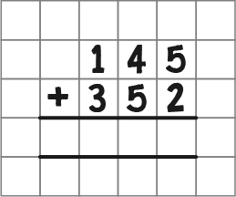
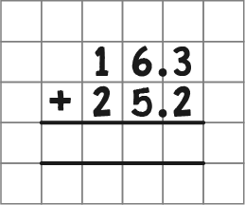
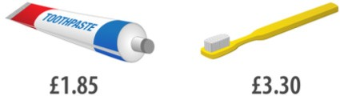

Q4 What is the total cost of a tube of toothpaste and a toothbrush?

Answer: £

Q5 Add together 1750 and 281

Answer:

Page 12

Adding Strengthen

Q1 Work out 135 + 17 + 133

Answer:

Q2 Work out 18.2 + 34.1 + 13.5

Answer:

Q3 Work out 15.6 + 8.76

Answer:

Q4 Calculate 17468 + 2606

Answer:

Page 13

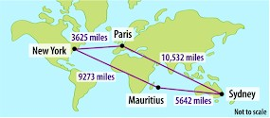
Adding Deepen

Q1 Fill in the gaps below to complete the calculation.

6 2

+ 1 9

8 2

1

Q2 In one week, a pilot flew from Paris to Sydney, from Sydney to Mauritius, from Mauritius to New York, then back to Paris from New York.
How many miles did he fly in total?

New York
3625 miles
Paris

10,532 miles

9273 miles

Mauritius

5642 miles

Sydney

Answer:

Q3 Add together the four numbers below.

27.49, 38, 9.78, 6.8

Answer:

Page 14

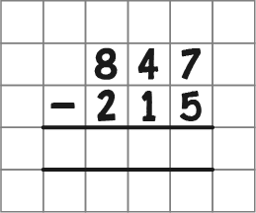
Subtracting Introduce

Q1 Complete the calculation below to work out 847 - 215

Answer:

Q2 Work out 3784 - 313

Answer:

Q3 Work out 646 - 271

Answer:

Q4 Work out 35.6 - 12.5

Answer:

Q5 Work out 56.4 - 13.7

Answer:

Page 15

Subtracting Strengthen

Q1 Rob has £154. He spends £82 on a new coat.
How much money does Rob have left?

Answer: £

Q2 Tyler went to the shop with £8.30. He spent £4.60 How much did he come home with?

Answer: £

Q3 Subtract 1549 from 1637

Answer:

Q4 Subtract 3.5 from 13.3

Answer:

Q5 Work out 2361.4 - 84.9

Answer:

Page 16

Subtracting Deepen

Q1 Add 238 to 567, then subtract 132 What is the answer?

Answer:

Q2 Grace is 1.45 m tall.
Jackson is 0.2 m shorter than Grace. How tall is Jackson?

Answer: m

Q3 Fill in the gap below to complete the calculation.

7 5 8

- 5 3

1 8 5

Q4 Jack has 14.4 m of rope.
Amy cuts off 2.68 m.
How much rope is Jack left with?

Answer: m

Page 17

Multiplying Introduce

Q1 Work out 720 x 10

Answer:

Q2 Work out 56 x 100

Answer:

Q3 Work out 17 x 3

Answer:

Q4 Work out 26 x 7

Answer:

Q5 Multiply 284 by 5

Answer:

Page 18

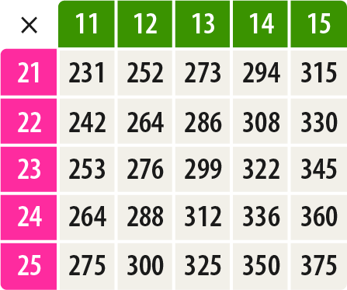
Multiplying Strengthen

Q1 Use the multiplication table below to calculate 22 x 14

Answer:

Q2 Work out 36 x 21

Answer:

Q3 Work out 17 x 503

Answer:

Q4 One table costs £63
How much would 502 tables cost?

Answer: £

Page 19

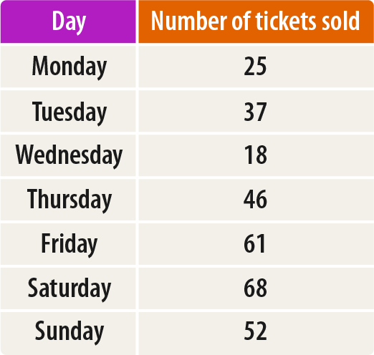
Multiplying Deepen

Q1 In the multiplication triangle below, the numbers in the circles multiply together to make the number in the rectangle in between.
Fill in the gap.

24

1824

69 76
5244

Q2 In the number pyramid below, each number is calculated by multiplying the two numbers below it.
Find the missing numbers in the number pyramid.

 |  |  | 144
4 |  | 4 |  | 36

Q3 A plane ticket to Vienna costs £194
This table shows the number of plane tickets to Vienna sold each day last week. How much money was spent on tickets to Vienna on Tuesday?

Answer: £

Page 20

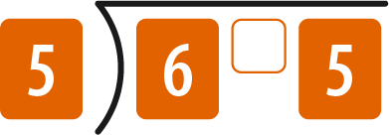
Dividing Introduce

Q1 Work out 720 ÷ 10

Answer:

Q2 What is 64.1 ÷ 10?

Answer:

Q3 I have 21 coins and want to arrange them into 3 equal groups.
How many coins will be in each group?

Answer:

Q4 What is the remainder when 23 is divided by 4?

Answer:

Q5 Work out 65 ÷ 5

Answer:

Q6 Divide 170 by 5

Answer:

Page 21

Dividing Strengthen

Q1 Work out the number that should go in the box to complete the calculation.

÷ 10 = 0.3

Q2 Divide 312 by 6

Answer:

Q3 Divide 266 by 7

Answer:

Q4 Anne has £144 to share between her 6 grandchildren for Christmas.
If she divides the amount equally between them, how much does each grandchild receive?

Answer: £

Q5 Calculate 288 ÷ 12

Answer:

Page 22

Dividing Deepen

Q1 A group of 4 friends has a bag of 47 sweets.
They divide the sweets equally between them.

- How many sweets does each friend receive?

- How many sweets are left over?

Q2 Bruce needs 26 burgers for a barbecue.
They are sold in packs of 6
How many packs does he need to buy?

a)
Answer:
b)

Answer:

Q3 Look at the two calculations below.
Use the top calculation to find the missing number in the calculation below it.

300 ÷ 12 = 25

300 ÷ = 50

Q4 777 will divide by 37 with no remainder.
What is the remainder when 775 is divided by 37?

Answer:

Page 23

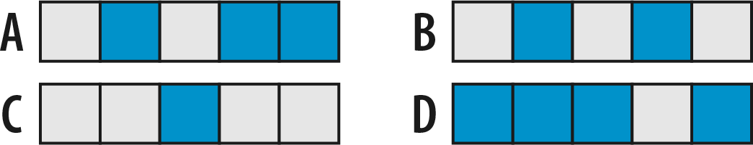
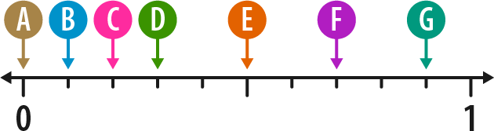
Fractions 1 Introduce

Q1 Which shape below is 2
5
shaded?

Answer:

Q2 What fraction of this shape is shaded?

Q3 What is two out of eleven written as a fraction?

Q4 The number line below is divided into 10 equal parts.

Answer:

Answer:

Which letter shows the position of 3
10
?

Answer:

Page 24

Fractions 1 Strengthen

Q1 Which two of the shapes are half shaded?

Answer: and

Q2 What fraction of the flag shown below is shaded?

Answer:

Q3 Write down the two shapes that are divided into quarters.
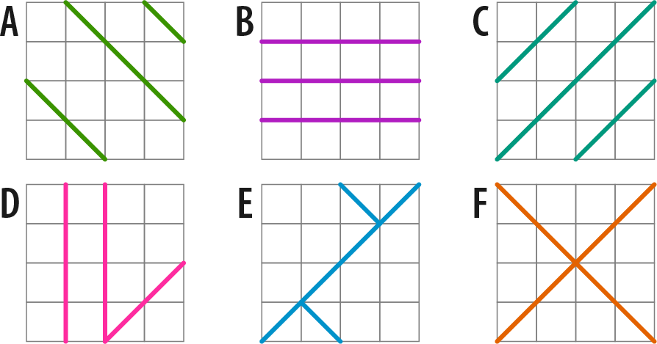

Answer:

and

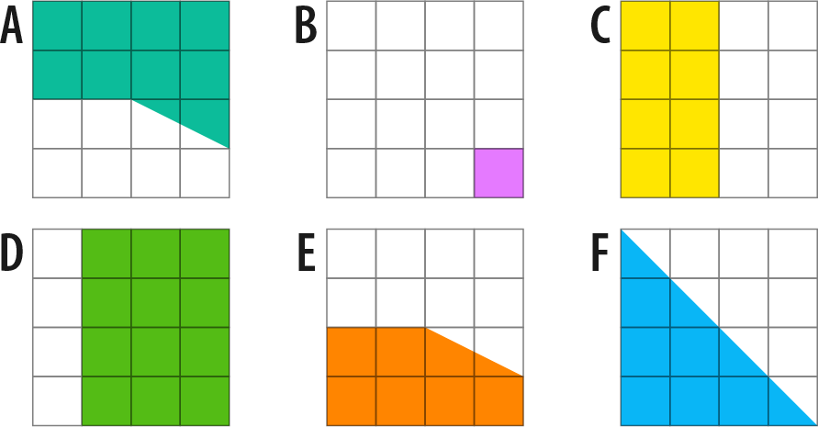
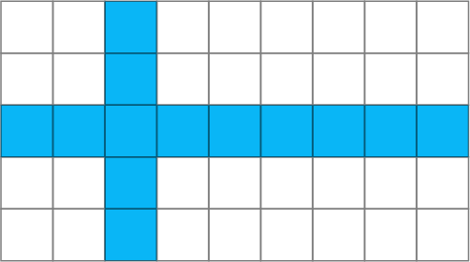

Page 25

Fractions 1 Deepen

Q1 Write down the two shapes are less than half shaded.
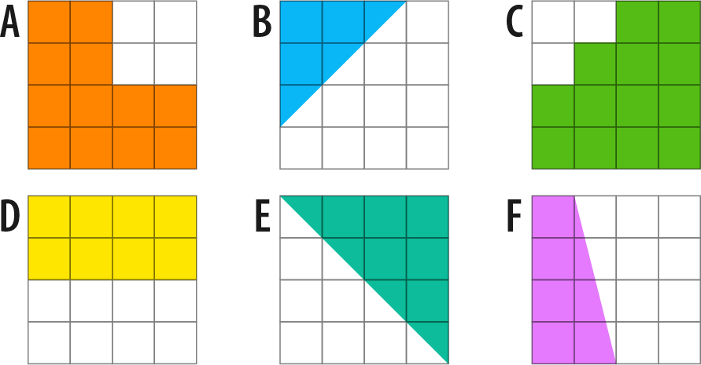

Q2 What fraction of £1 is 17p?

Answer:

and

Answer:

Q3 What fraction of an hour is 23 minutes?

Answer:

Q4 Which two of the shapes below are 3
4
shaded?

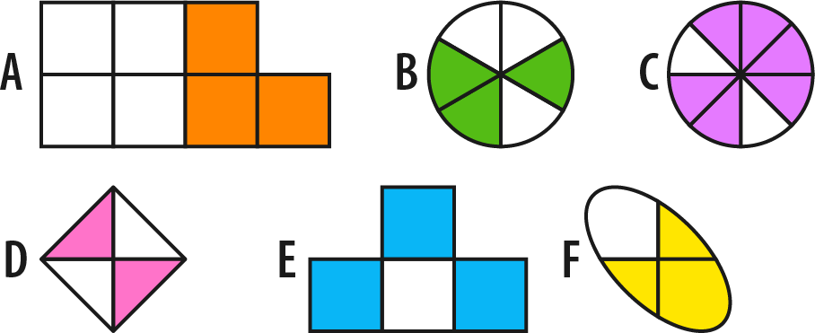

Answer: and

Page 26

Fractions 2 Introduce

Q1 What is the missing number in these equivalent fractions?

5 = 20
2

Q2 Simplify 2
10

Answer:

Q3 What fraction of the shape below is shaded?
Give your answer in its simplest form.

Answer:

Q4 Put these fractions into ascending order (smallest to largest):

7 ,
10
2 , 3
10 10

Answer:

Page 27

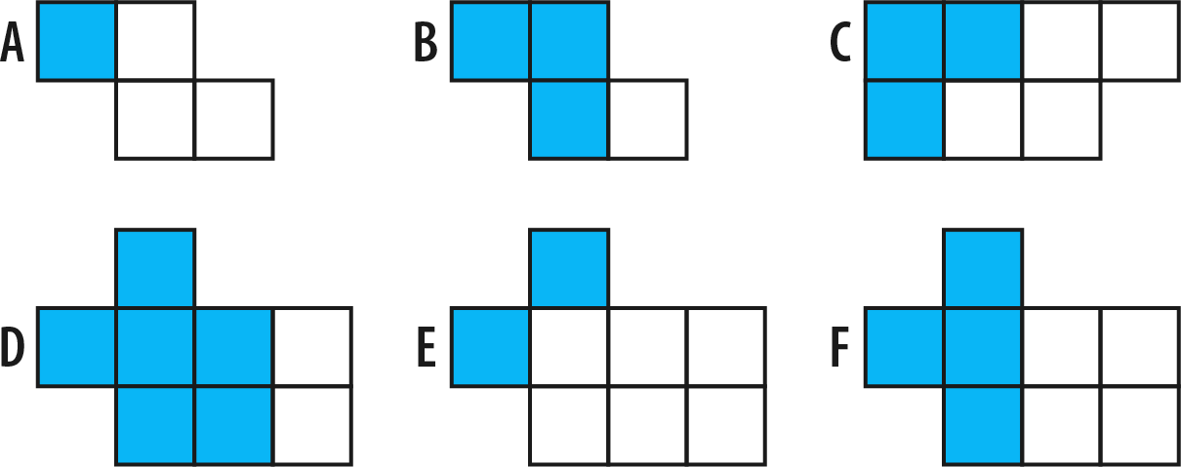
Fractions 2 Strengthen

Q1 Put these fractions into ascending order (smallest to largest):

3/4 1/5 4/8

Answer:

Q2 Which two shapes are 3
4
shaded?

Answer: and

Q3 Use two of the cards below to make a fraction that is equivalent to 16
20
1 2 4 5 10 16

16 =
20

Q4 Complete this equality to find the three equivalent fractions.

1 = 3 =
4 20

Page 28

Fractions 2 Deepen

Q1 Hamza makes a cake and cuts it into 16 equally sized pieces.
He gives 12 pieces to Jack.

What fraction of the cake does Hamza have left? Give your answer in its simplest form.

Answer:

Q2 Jan says that the same fraction of each rectangle below has been shaded.
Is Jan correct?
Write a sentence to explain your answer.

Answer:

Q3 What fraction is exactly halfway between 4
5
and
14 ?
15

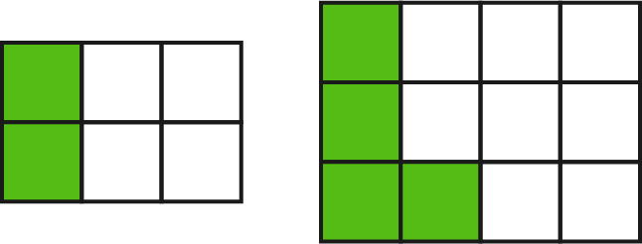

Answer:

Page 29

Prime numbers and factors Introduce

Q1 Work out all the factors of 10 by completing the factor pairs below.

10 = x

10 = x

Q2 Work out all the factors of 14

Answer:

Q3 Which two numbers complete the following sentence?

7 is a prime number because it only has two distinct factors, which are and

Q4 For each number, decide whether it is prime or not prime: a)
- 5

- 1
- 8
Answer: b)
c)

Q5 Find all of the prime numbers from the list: 11, 18, 1, 17, 21, 14

Q6 Write out all of the prime numbers between 0 and 10

Answer:

Answer:

Page 30

Prime numbers and factors Strengthen

Q1 Which number in the list below is not prime?

13, 15, 19, 17 11

Answer:

Q2 Find all the factors of 20

Answer:

Q3 Which three of the numbers below are factors of 100?

2, 9, 10, 25, 35, 200

Answer: , and

Q4 How many factors does 40 have?

Answer:

Page 31

Prime numbers and factors Deepen

Q1 For each number, decide whether it is prime or not prime:
a) 51
b) 87
c) 59
a)

Answer: b)

c)

Q2 What is the largest two-digit prime number?

Answer:

Q3 Find two primes which add to make 28 What is the difference of these two primes?

Answer:

Page 32

Area and perimeter Introduce

Q1 What is the area of this rectangle?

Answer:
cm2

Q2 What is the perimeter of this triangle?

Answer: cm

Q3 What is the area of this rectangle?

Answer:
cm2

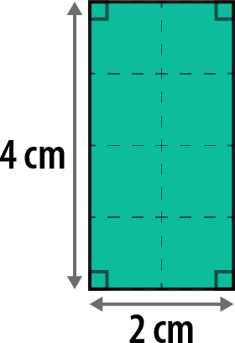
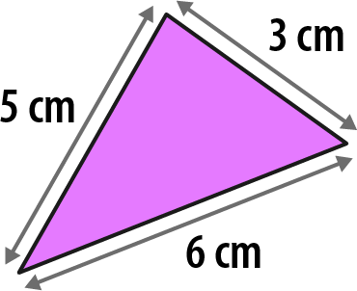
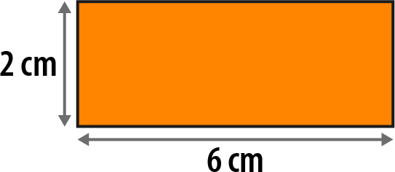
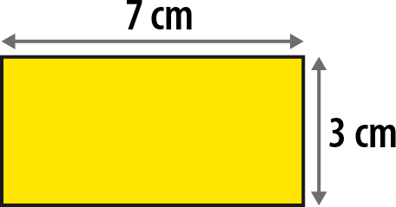

Q4 What is the perimeter of this rectangle?

Answer: cm

Page 33

Area and perimeter Strengthen

Q1 What is the area of this rectangle?

Answer:
cm2

Q2 Work out the area and perimeter of this rectangle.

Area:
cm2

Perimeter: cm

Q3 What is the area of this square?

Answer:
cm2

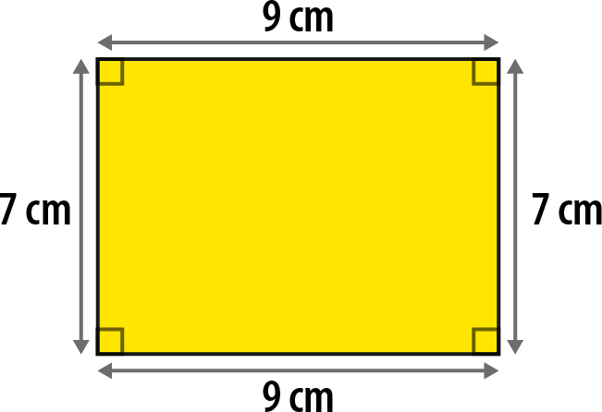
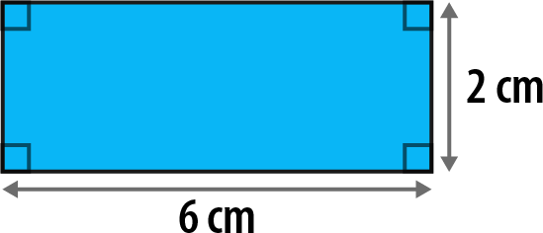
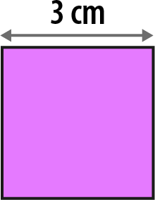
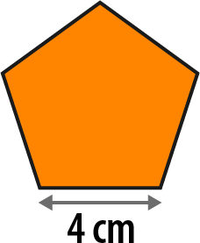

Q4 Calculate the perimeter of this regular pentagon.

Answer: cm

Page 34

Area and perimeter Deepen

Q1 Work out the perimeter of this shape.

Answer: cm

Q2 What is the length of the unknown side in this rectangle?

Answer: cm

Q3 What is the length of one side of this regular pentagon?

Answer: cm

Q4 A rectangle has an area of 24 cm2.
How long could the sides of the rectangle be? Give three different examples.

Answer:

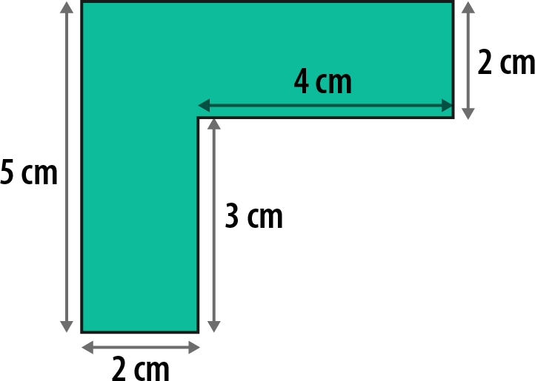
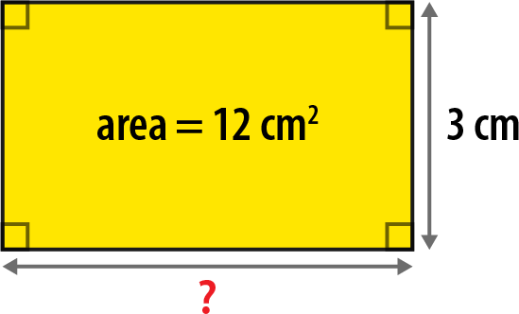
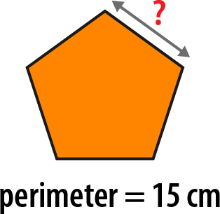

Page 35

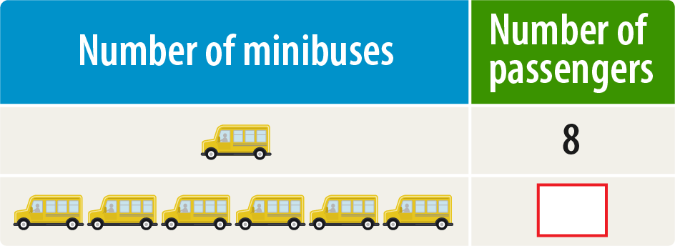
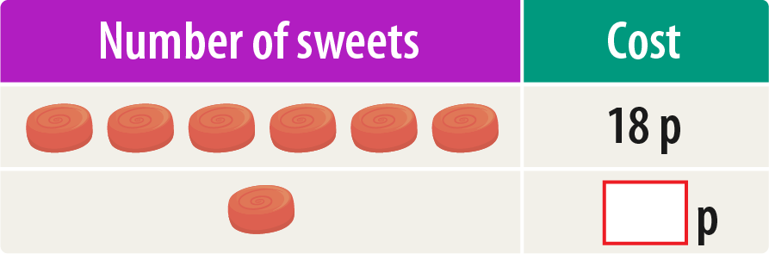
Ratio relationships Introduce

Q1 1 minibus can seat 8 passengers.

How any passengers can be seated on 6 identical minibuses?

Q2 A recipe to serve 4 people uses 200g of flour.

How much flour is needed to make the same recipe to serve 8 people?

Answer: g

Q3 Asher buys 6 identical sweets that cost 18p in total.

How much does 1 of the sweets cost?

p

Page 36

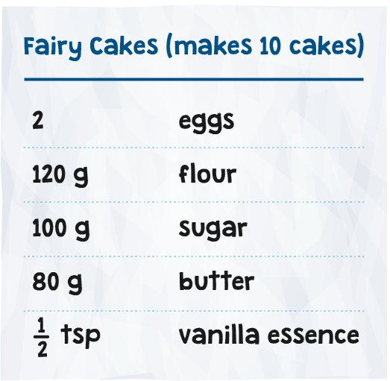
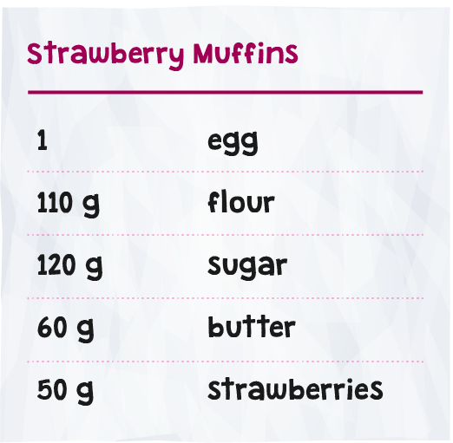
Ratio relationships Strengthen

Q1 Imran is making fairy cakes using the recipe below. How much flour is needed to make 20 fairy cakes?

Answer: g

Q2 Johanna is baking chocolate biscuits.
The recipe she is following uses 150g of sugar and makes 30 biscuits.

If Johanna only has 50g of sugar then how many of these biscuits can she make?

Answer:

Q3 Indie makes some strawberry muffins following the recipe provided.
If Indie uses 550g of flour, how many grams (g) of strawberries must she use?

Answer: g

Page 37

Ratio relationships Deepen

Q1 Alice buys 10 identical toy boats and spends £80 in total.
How much would 7 toy boats cost?

Answer: £

Q2 Finn is stacking identical cube-shaped boxes.
He stacks 7 boxes to make a tower that is 112cm tall. He adds 1 more box to the tower.
How tall is the tower now?

Answer: cm

Q3 Mia wants to predict how many times her heart will beat in an hour.
When she is resting, her heart beats 5 times in 6 seconds.

- Use this information to predict the number of times her heart will beat in 1 minute.

Answer: a)

- Predict the number of times her heart will beat in 1 hour.

Answer: b)

Page 38
Page 38

